
tihahhah

Kiloview Electronics Co., Ltd.

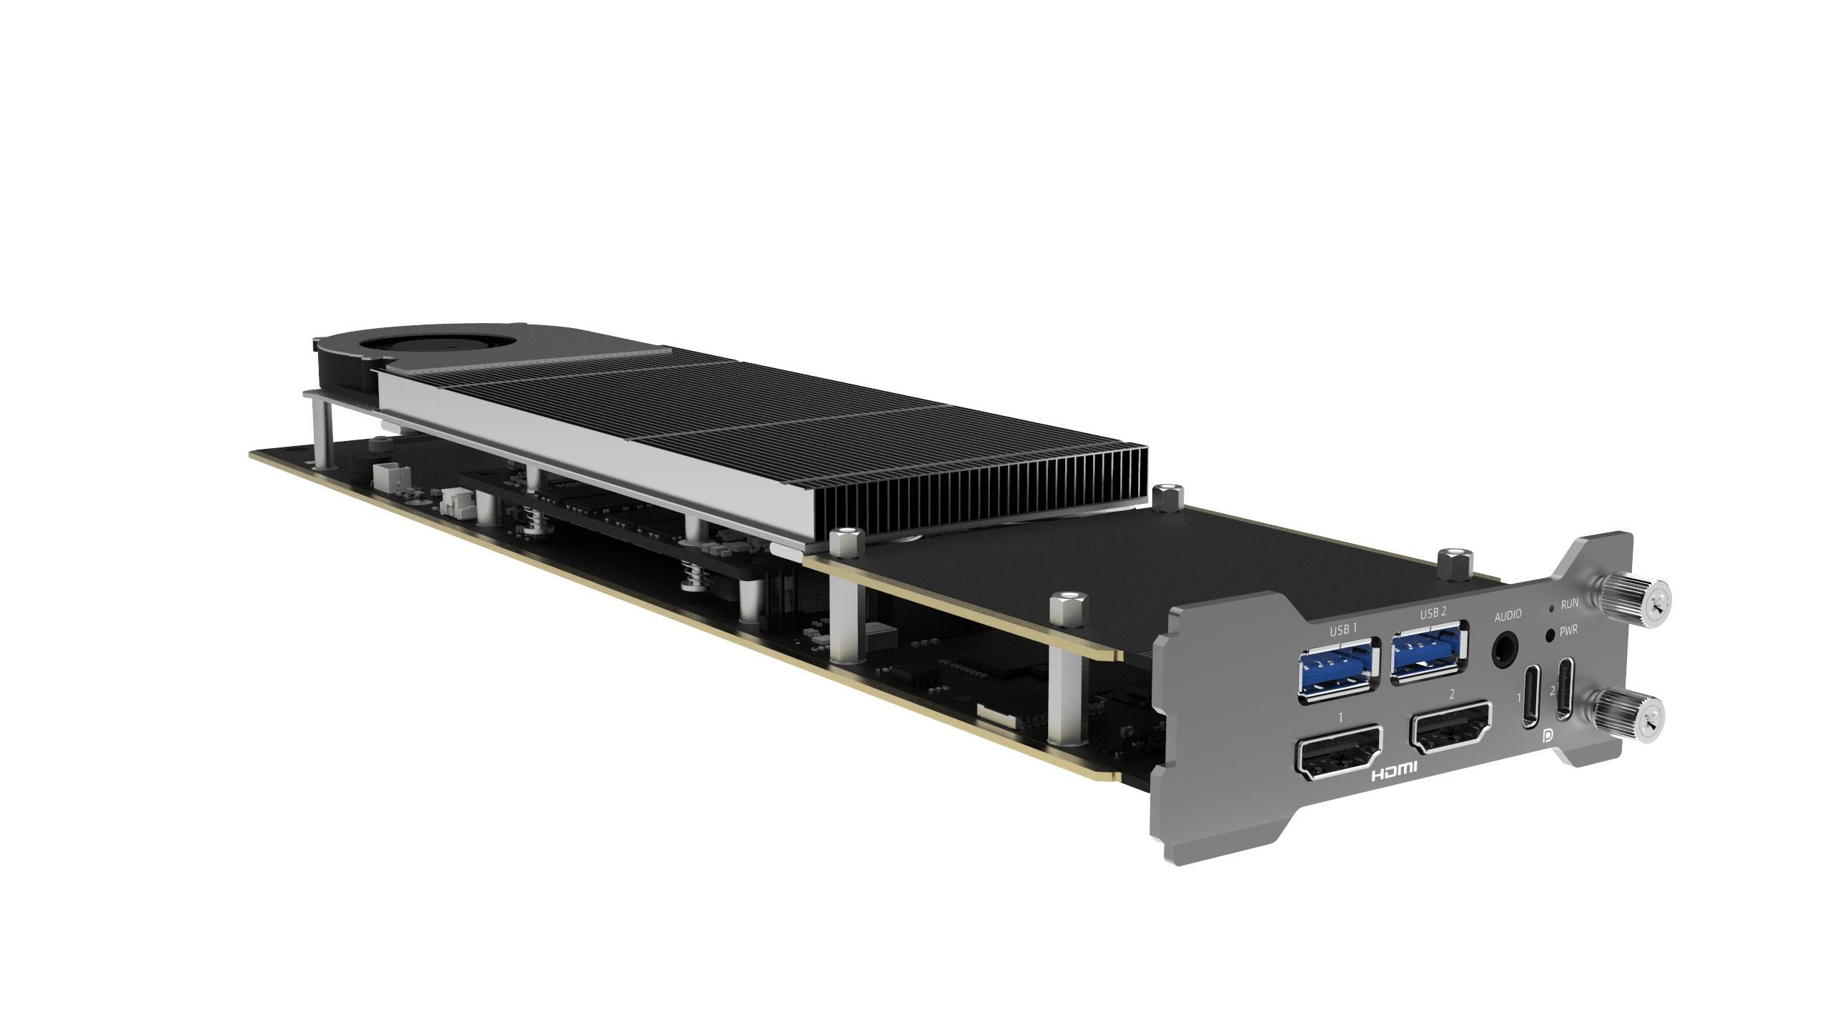

FXC-A8800 Compute Card
User Manual

LEGAL NOTICE
By receiving this document from Kiloview Electronics Co., Ltd. (hereinafter referred to as "Kiloview"), you agree to the following terms. If you do not agree, please stop using this document.
This document is the copyright of Kiloview Electronics Co., Ltd. All rights not expressly granted herein are reserved. This document contains proprietary information of Kiloview. No part of this document, including any images, tables, data or other information, may be reproduced, transmitted, distributed, used or disclosed without prior written permission from Kiloview.
is a registered trademark of Kiloview. Product names and logos of Kiloview are trademarks or registered trademarks of Kiloview. Other product or company names mentioned in this document may be trademarks or registered trademarks of their respective owners. Reading this document does not grant the reader any rights, whether by implication, estoppel or otherwise, to use any marks appearing herein without the prior written consent of Kiloview or the relevant third-party rights holder.
This product has been designed to comply with applicable environmental and personal safety requirements. Storage, use, and disposal of the product must follow the instructions in this manual, relevant contracts, and applicable local laws and regulations.
This document is provided "as is" and "as available". The information herein is subject to change as Kiloview products and technology evolve; Kiloview is under no obligation to notify you of such changes.
For matters not covered in this document, please visit www.kiloview.com for further information and technical support.

Applicable Model Description
This user manual applies to the Kiloview FXC-A8800 series compute cards.
The series is designed specifically for the Kiloview RF02 rack-mount platform.
It adopts a modular design, differentiated by onboard memory capacity +
standard NVMe SSD capacity into four configuration models. The core hardware is identical; only storage configurations differ. The models are as follows:
- FXC-A8800-16G/1T: 16 GB DDR5 memory + 1 TB NVMe PCIe SSD
- FXC-A8800-16G/2T: 16 GB DDR5 memory + 2 TB NVMe PCIe SSD
All models in this series use the AMD Ryzen Embedded 8845HS processor. The interfaces, system configurations, and management methods described in this manual apply across the entire series. For specific product features, please refer to the official specifications of your purchased model.

Table of Contents
1 Product Overview 5
1.1 Key Features 5
1.2 Technical Specifications 7
2 Package Contents & Interface Description 10
2.1 Package Contents 10
2.2 Interface Description 10
3 Hardware Installation 11
4 Operating System Installation 13
4.1 Connecting External Keyboard, Mouse & Display 13
4.2 OS Installation Procedure 13
4.2.1 Insert Boot Drive and Restart 13
4.2.2 Enter BIOS/UEFI Setup 14
4.2.3 Adjust Boot Order 14
4.2.4 Save Settings and Exit 14
4.2.5 Enter Ventoy Image Selection Menu 16
4.2.6 Select Target OS Image (Pre-installed Image Recommended) 16
4.2.7 Complete OS Installation (Windows 11 Pre-installed Image Example) 18
4.2.8 Initial Setup After Reboot 18
4.2.9 Enter Desktop and Verify Hardware 20
4.3 Install the RF02 Client on the Compute Card 21
5 Device Status 24
5.1 Log In to the RF02 Management Platform 24
5.2 Module Card Status Display 25
5.3 Power On/Off via LCD Screen 26
5.4 Manage Compute Card via RF02 Platform 28
5.5 Configure Compute Card IP via RF02 30
5.6 Manual Power-On 32
6 Remote Control via RF02 32
6.1 Enable Remote Desktop 32
6.2 Set Login Password 33
6.3 Connect to Remote Desktop 34
7 System Links & Network Access 35
7.1 Core Link Architecture 35
7.2 Signal Routing Between Compute Card and Internal Modules 36
7.2.1 Signal Routing with Codec Cards 36
7.2.2 Signal Routing with Media Gateway Cards 37
7.3 External Network Access to the Compute Card 38
7.3.1 Core Access Rules 38
7.3.2 Physical Layer Link 38
7.4 Audio Signal Routing & Configuration 38
7.4.1 Audio Hardware Interfaces & Core Link Architecture 38
7.4.2 System-Level Audio Device Recognition & Basic Routing 40
7.4.3 Audio Configuration for Major AV / Mixing Software 41
7.4.4 Audio Configuration Troubleshooting 43
7.5 Network Access Configuration 44
8 Video Production Software Configuration 45
8.1 General Prerequisites 45
8.2 vMix Pro Optimization 45
8.3 OBS Studio Optimization 46
8.4 General Operating Notes 47
8.5 Free Trial License Information 47
9 Storage Expansion Guide 47
9.1 Before You Begin 48
9.2 SSD Installation Steps 48
10 FAQ 51

Product Overview
The FXC-A8800 is an x86-architecture modular compute card based on the AMD Ryzen Embedded 8000 platform, purpose-built for integration into the Kiloview RF02 modular rack chassis. As the high-performance computing component of the RF02 AV processing ecosystem, it works in concert with the codec and gateway cards inside the chassis to deliver an end-to-end live production and broadcasting solution covering capture, processing, and output. The card features the AMD Ryzen Embedded 8845HS processor with an integrated Radeon 780M GPU, dual 10 GbE internal communication interfaces, and multi-channel 4K display outputs — providing robust hardware support for running mainstream production software such as vMix and OBS, as well as 4K video encoding/decoding and lightweight AI inference.

Key Features
- High-Performance Core Architecture
Based on AMD Ryzen™ Embedded 8845HS Zen 4 architecture, this compute card integrates 8-core / 16-thread high-performance CPU,RDNA 3 architecture GPU and 16 TOPS dedicated NPU delivering NPU , complemented by DDR5 5600MHz high-frequency memory and dual 10GbE internal high-speed interconnect interfaces, delivering dense computing power for 4K video codec workloads and lightweight AI inference

- Cross-Platform OS Support
Full support for Windows and Linux mainstreamdistributions. Deeply optimized and validated hardware drivers are included, ensuring full performance and functionality in all supported OS environments.

- Multi-Channel Encode/Decode Capability
Leveraging the RDNA 3 architecture's integrated hardware acceleration engine, this compute card delivers exceptional H.264/H.265 hardware encode/decode performance:
- Decode-only: single card supports up to 6 streams of 4K or 17 streams of 1080P concurrent real-time decoding.
- Simultaneous Encode + Decode：
  - H.265: supports 2× 4K@60fps or 6× 1080p@60fps simultaneous encode and decode.
  - H.264: supports 1× 4K@60fps or 4× 1080p@60fps simultaneous encode and decode.

- High-Bandwidth Memory & High-Speed Storage
Onboard 16 GB DDR5-5600 MHz dual-channel memory, paired with 2× M.2 2280 NVMe PCIe SSD slots supporting 1 TB/2 TB pre-installed high-speed SSDs for a fast storage array. This configuration satisfies the demands of multi-channel 4K video processing, large-file caching, and low-latency I/O, with ample expansion headroom for future upgrades to ensure system stability and smooth operation under broadcast-grade heavy loads.

- Native RF02 Ecosystem Integration
As the standard computing unit for the RF02 chassis, each card occupies 2 consecutive standard card slots and achieves unified power supply, centralized management, and high-speed data exchange with other module cards in the chassis — the core hardware module for building a high-density, all-in-one AV processing pipeline，A single RF02 chassis supports up to 4 compute cards of this series.

- Broad Software Compatibility & Bundled Software Suite
Stable software runtime environment compatible with vMix, OBS Studio and other mainstream broadcast production software. Also includes freeperpetuallicenses for Kiloview tools (including Kilolink Server Pro、Multiview, NDI Recorder, and more), effectively extending the boundaries of your production workflow.

- Long-Term Supply Assurance (Industrial-Grade CPU)
Using AMD Ryzen Embedded industrial-grade embedded processor (non-consumer-grade embedded product line），Kiloview with a 10-year product lifecycle supply commitment (for this industrial-grade embedded CPU), effectively mitigating the risk of discontinuation due to rapid consumer-grade hardware iteration — perfectly suited to the long-service-life demands of broadcast equipment.

Technical Specifications
General Specifications
Processor（CPU） | CPU : AMD Ryzen Embedded 8845HS  - Cores/Threads: 8 cores / 16 threads  - Architecture: AMD Zen 4  - Clock: Base 3.8 GHz / Boost up to 5.1 GHz  - L3 Cache: 16 MB | L2: 8 MB | L1: 512 KB
GPU | Architecture：AMD RDNA 3  - Compute Units (CU): 12 CU (768 Stream Processors, 6 WGPs)  - Hardware Units: 48 TMUs, 32 ROPs, 12 Ray-Tracing Cores  - Max Core Frequency: 2700 MHz  - Video Codec:  Hardware Accelerated: H.264 / H.265 / AV1 / VP9 / MPEG2  Decode: Single engine 8K@60fps  Encode: Single engine 8K@60fps
NPU | Architecture: AMD XDNA AI  - Peak AI Performance: 16 TOPS  - Combined Performance (CPU+GPU+NPU): 39 TOPS
Memory | Onboard: 16 GB DDR5  - Dual-Channel  - Speed: 5600 MHz
Storage Expansion | 2 x M.2 2280 slots  - Supports NVMe PCIe SSD  - Pre-installed options: 1 TB or 2 TB high-performance NVMe SSD
Video Output | 2 x HDMI 2.1 (supports 4K@60Hz)  2 × USB Type-C (supports DisplayPort Alt Mode, 4K@60Hz)  Note: When all 4 outputs are active simultaneously, a maximum of 3 outputs support stable 4K@60Hz
Audio Interface | 1 x 3.5 mm Line Out
Network Interface | 2 x 10 GbE RJ45 (for RF02 internal communication only)  Note: Full 10 Gbps speed is available when installed in slots 17–18 of the RF02 chassis; other slots support up to 2.5 Gbps
USB Interfaces | - 2 × USB 3.2 Gen1 (Type-A)  - 2 × USB 3.2 Type-C (DP 1.4 Alt Mode)
Power Input | 12 VDC - 19 VDC (powered by RF02 chassis internally)  Note: A single RF02 chassis supports up to 4 compute cards of this series
Operating Environment | Temperature: 0°C - 40°C  Humidity: 5% - 95% RH (non-condensing)
Storage Environment | Temperature: -15°C - 45°C  Humidity: 20% - 75% RH (non-condensing)
Max Power Consumption | 88W
Physical Dimensions | Full card (baseplate)：76.84 mm (W) × 331.68 mm (L) × 1.6 mm (thickness)  Core board: 70 mm (W) × 110 mm (L) × 2 mm (H)  Weight: 0.7 kg  Note: Each card occupies 2 consecutive standard slots in the RF02 chassis

PassMark 11.1 Benchmark Results

Index | Score
PassMark Overall Score | 6368.9
CPU Mark (Multi-core) | 28779.9
3D Graphics Mark (G3D) | 6474.7
Memory Mark | 2868.2
Disk Mark | 16736.8

PassMark CPU/GPU Performance Reference

Hardware | Config | Reference
Processor（CPU） | AMD Ryzen Embedded 8845HS | Multi-core performance comparable to Intel Core i5-12600K (PassMark 27588) and Apple M2 Max 12-Core (PassMark 26847)
Graphics（GPU） | AMD Radeon 780M (RDNA 3) | Graphics performance comparable to NVIDIA GeForce GTX 1050 Ti (PassMark 6355) and NVIDIA GTX 1650 Ti (PassMark 6610)

Package Contents & Interface Description

Package Contents
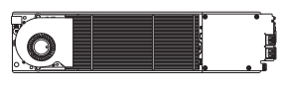 | 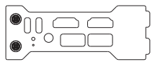
- Compute Card PCB x 1 | - Slot Bracket x 1
 | 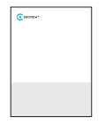
- Certificate / Warranty Card x 1 | - Quick Start Guide x 1
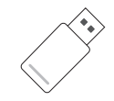
- System Installation USB Drive x 1

Interface Description

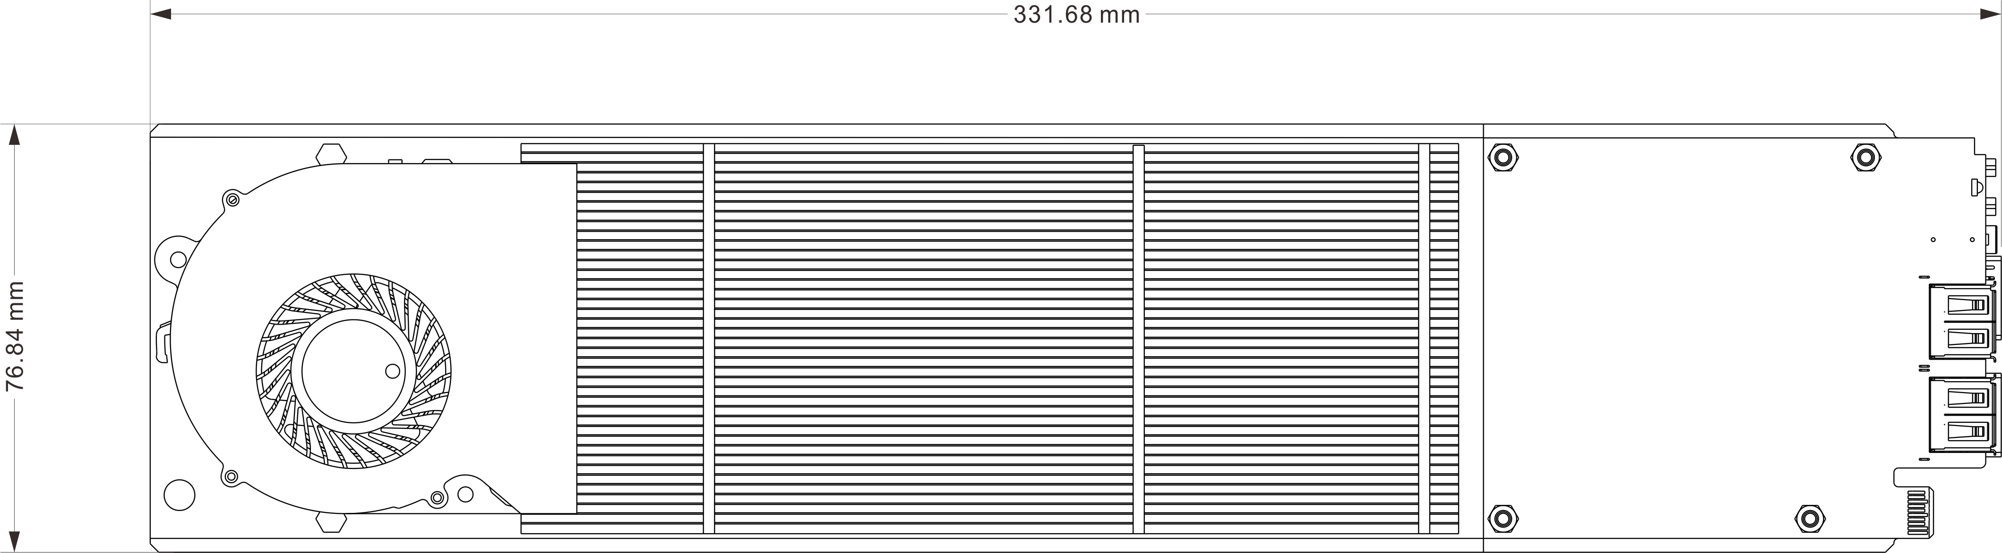

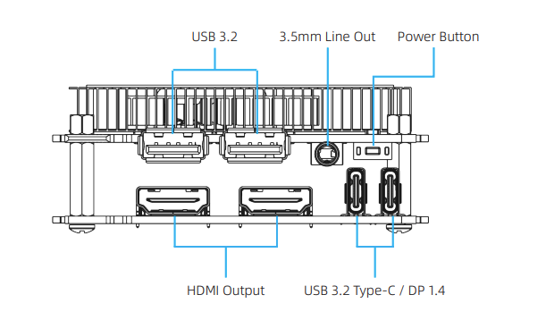
FXC-A8800 Compute Card Interface Diagram

3 Hardware Installation
Step 1: Remove the rear blanking panel from the corresponding slot on the RF02 chassis. Install thebracket included with the compute card.compute cardbracket。

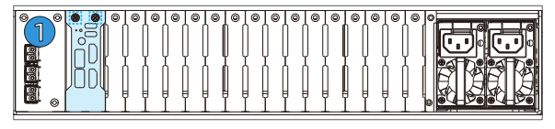

Step 2: Loosen the two captive thumb screws（(a and b)） on the RF02 front panel and open the chassis.
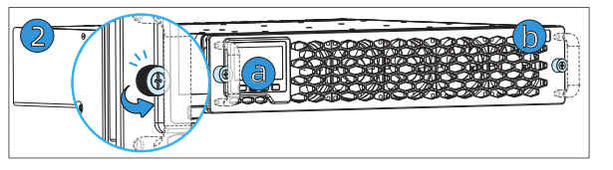
Step 3: Locate the metal latch (d) at the rear end of the card slot. Slide the latch to the right, then down, to release the locking mechanism.。
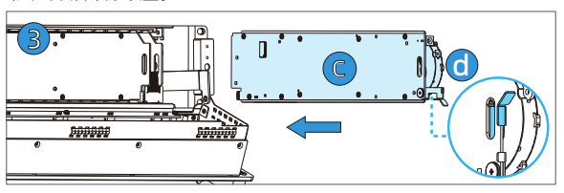
Step 4: Align the compute card (C) with the slot (short-pin edge connector facing down). The card occupies 2 consecutive RF02 slots. Slide it in horizontally until fully seated. Flip the metal latch up then to the left to lock the card in place. Close the front panel.
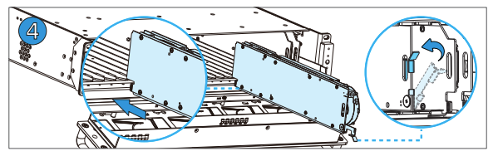
Before installation, confirm the slot number. Each slot position on the RF02 chassis is marked with a number printed on the bottom of the chassis below the slot, as shown below. Select the correct slot based on these numbers.
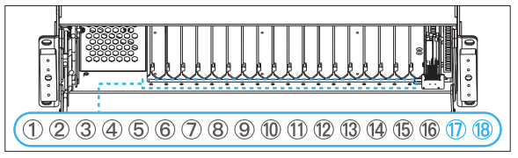

Note:
1.Due to the chassis design, the FXC-A8800 compute card cannot be inserted into slot combinations 4–5, 10–11, or 16–17. Forcing insertion may damage the interfaces.
2.For a single FXC-A8800, slots 17–18 are recommended for full 10 Gbps speed. All other valid slot combinations support up to 2.5 Gbps.

Step 5: Install the included compute card bracket on the RF02 rear panel and tighten the screws.
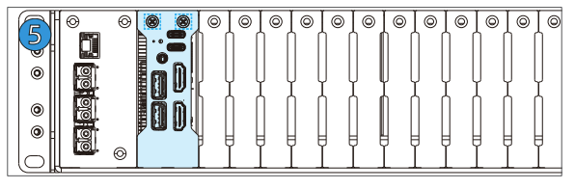

Step 6: Tighten thumb screws a and b. Installation is complete.
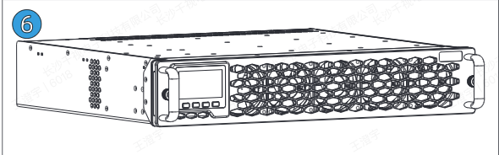
To remove: loosen the 2 thumb screws on the RF02 front panel, release metal latch (d), then slide the compute card (c) straight out.

[Hot-Swap Warning] Before removal, you must first execute a "Shutdown" operation via the RF02 Management Platform or LCD screen. Wait until the compute card has fully powered off and the indicator LED is off before proceeding with removal.

Operating System Installation

Connecting External Keyboard, Mouse & Display
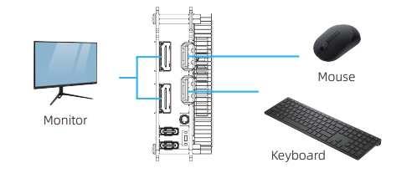
Before installing an operating system, connect an external keyboard, mouse, and display to the compute card's expansion ports.

OS Installation Procedure

Step 1: Configure the compute card to boot from the included USB drive (BIOS/UEFI setup)

Insert Boot Drive and Restart
Action: Insert theincludedboot drive into a USB port on the FXC-A8800 compute card (the onboard USB 3.2 Type-C port is recommended for more stable connection). Power on the compute card (or restart if already running).

Enter BIOS/UEFI Setup
Action: Immediately and repeatedly press the [Delete] key as the compute card powers on until the BIOS/UEFI interface appears.

Adjust Boot Order
Action:
- Navigate: After entering BIOS, use the arrow keys to navigate to “Save & Exit” at the top.
- Select boot device: In the “Boot Option Priorities”(Boot Option Priorities) list, locate your USB drive (usually shown as "UEFI: [drive name]").
- Adjust order: Use the “+” / “-” keys to move the USB drive to “Boot Option #1” (Boot Option #1).
- Save and exit: Navigate to the “Save & Exit” menu and select “Save Changes and Exit” (Save Changes and Exit), then confirm. The compute card will reboot and enter the OS installation screen.

Save Settings and Exit
Action: Press [F10] (or click [Save & Exit Setup] in the interface). Select [Yes] in the confirmation dialog. The compute card will reboot and boot from the included U drive.
⚠️ Reminder: If you are unfamiliar with BIOS/UEFI operations,please contact technical support for assistance.
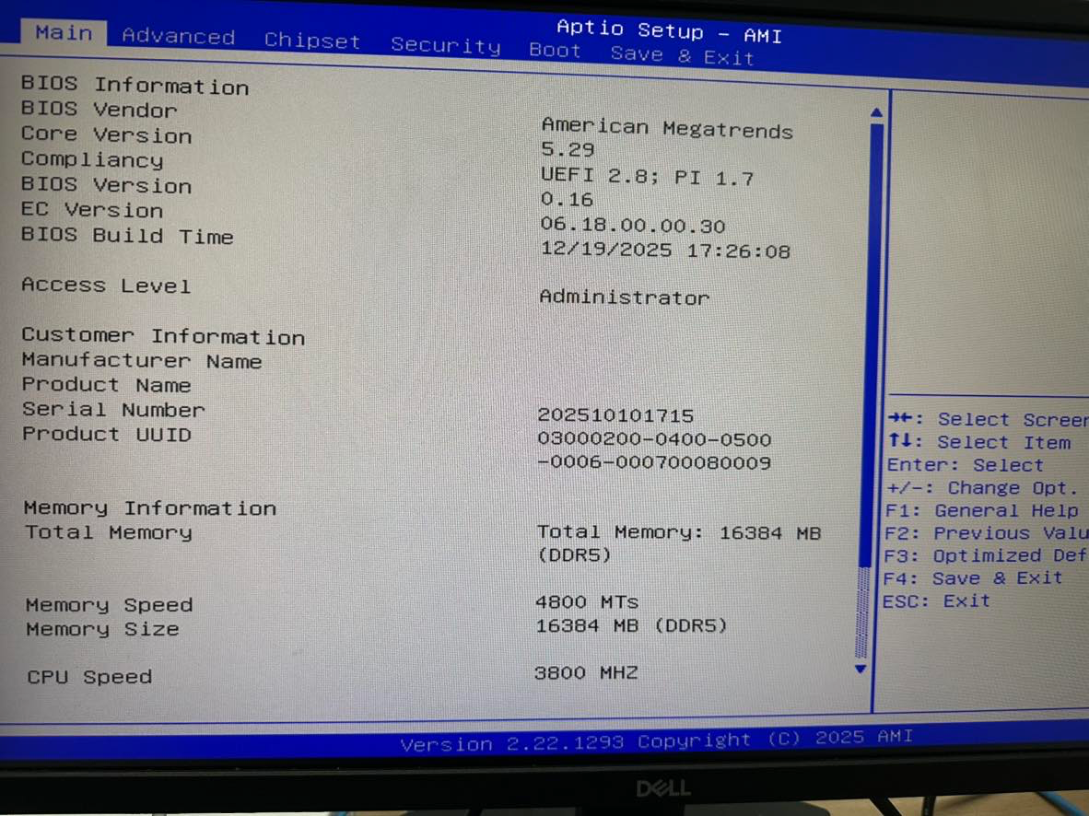

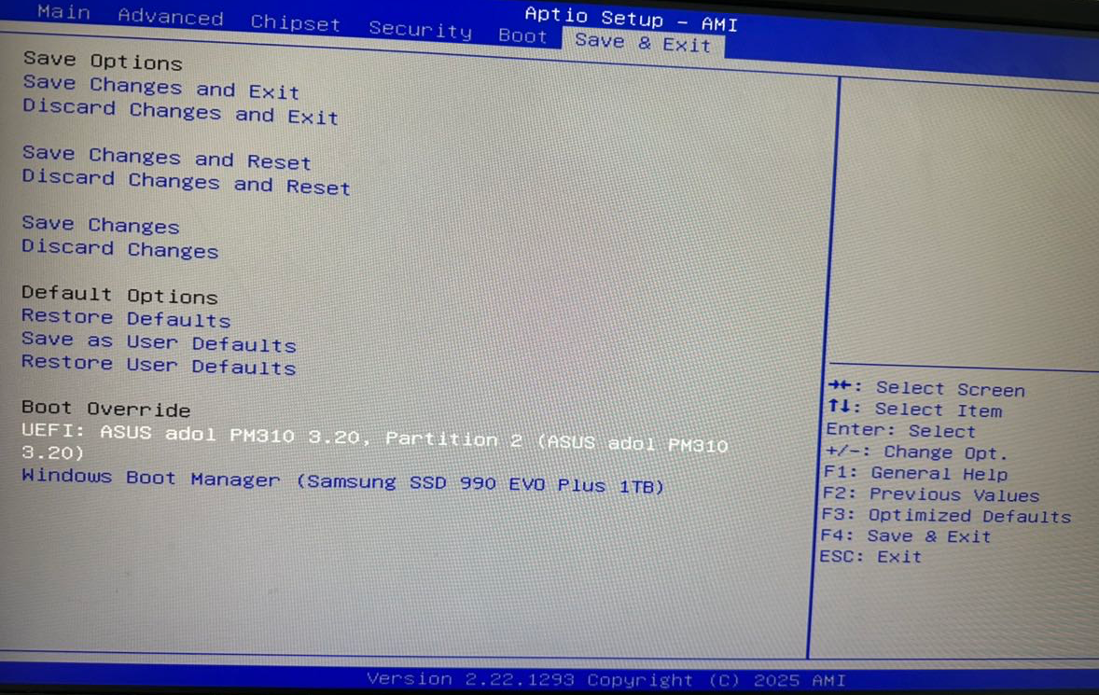

Step 2 : Boot and begin installation (hardware-optimized for compute card)

Enter Ventoy Image Selection Menu
Action: After reboot, the compute card automatically enters the Ventoy selection screen, which lists all OS images on the boot drive (pre-installed and added), for example:ubuntu-20.04.6-desktop-amd64.iso (pre-installed),Win11_24H2_Pro_Src_Chinese_Simplified_amd64_Custom.iso (pre-installed),
「Win10_22H2_Pro_Chinese_Simplified_amd64.iso (added).

Select Target OS Image (Pre-installed Image Recommended)
Action: Use the up/down arrow keys to select the desired OS image. The pre-installed image (e.g., Win11_24H2_Pro_Src_Chinese_Simplified_amd64_Custom.iso) is recommended as it is already optimized for FXC-A8800 hardware. Press [Enter] to confirm.

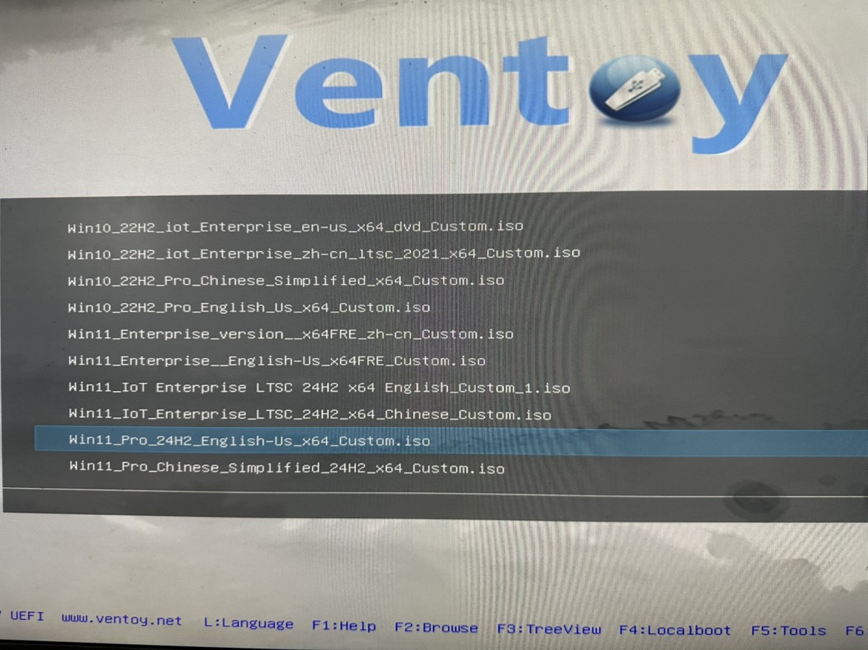
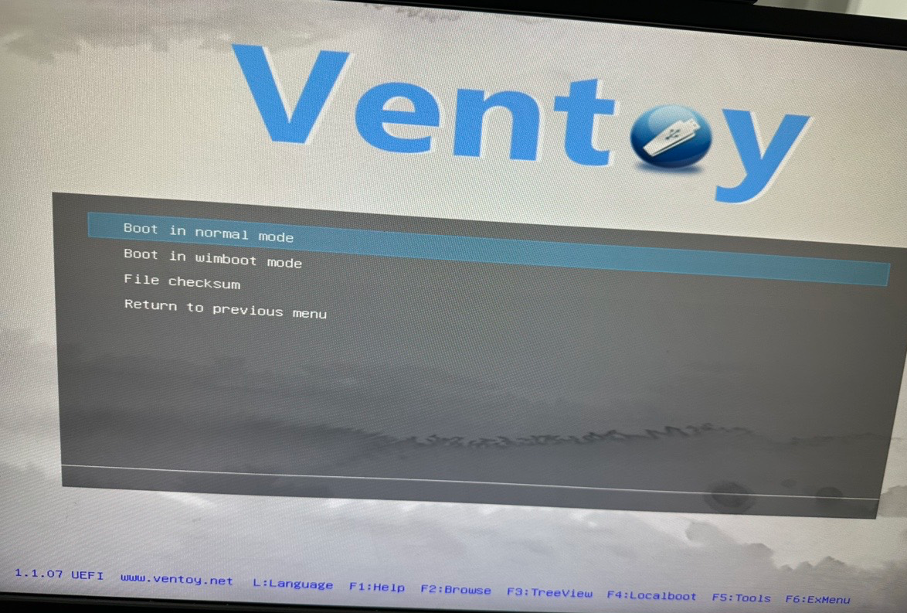

Complete OS Installation (Windows 11 Pre-installed Image Example)
Action:
- After the image loads, the Windows Setup screen appears. Select the installation language (default: Chinese), time zone, and click [Next].
- Read and accept the Microsoft License Agreement. On the installation type screen, select [Custom: Install Windows only (advanced)].
- The system will automatically copy files, expand components, install features and updates, and reboot several times. No manual intervention is needed — do not remove the USB drive or power off. The pre-installed image is pre-optimized for the FXC-A8800's AMD Ryzen 7 8845HS and Radeon 780M GPU; no additional basic drivers are required after installation.
Step 3Step 3: System Initialization (post-installation setup)

Initial Setup After Reboot
Action: After installation completes, the system reboots automatically and enters the initial configuration screen. Follow these steps:
- Select region and language (defaults match the pre-installed image environment; click [Next] to proceed).
- Accept the end-user license agreement and data cross-border transfer terms (follow the on-screen prompts; default selections are fine).
- Create a user account: set a username and login password. (You may choose password-free login, but a password is required for Remote Desktop access.)
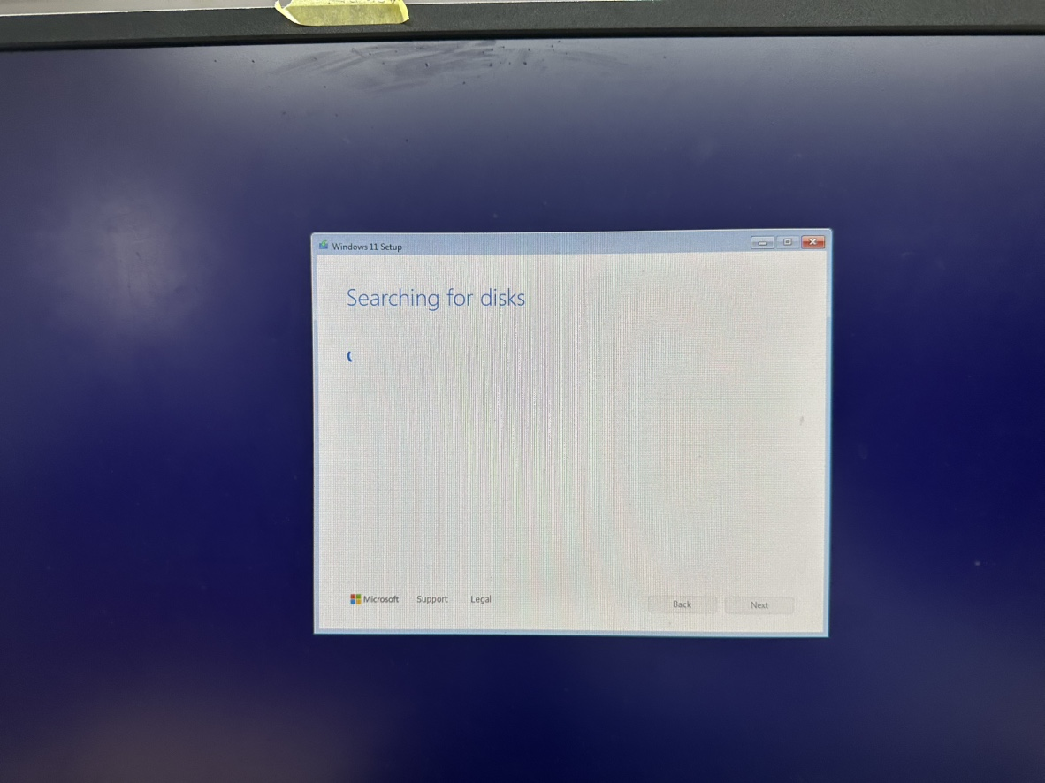
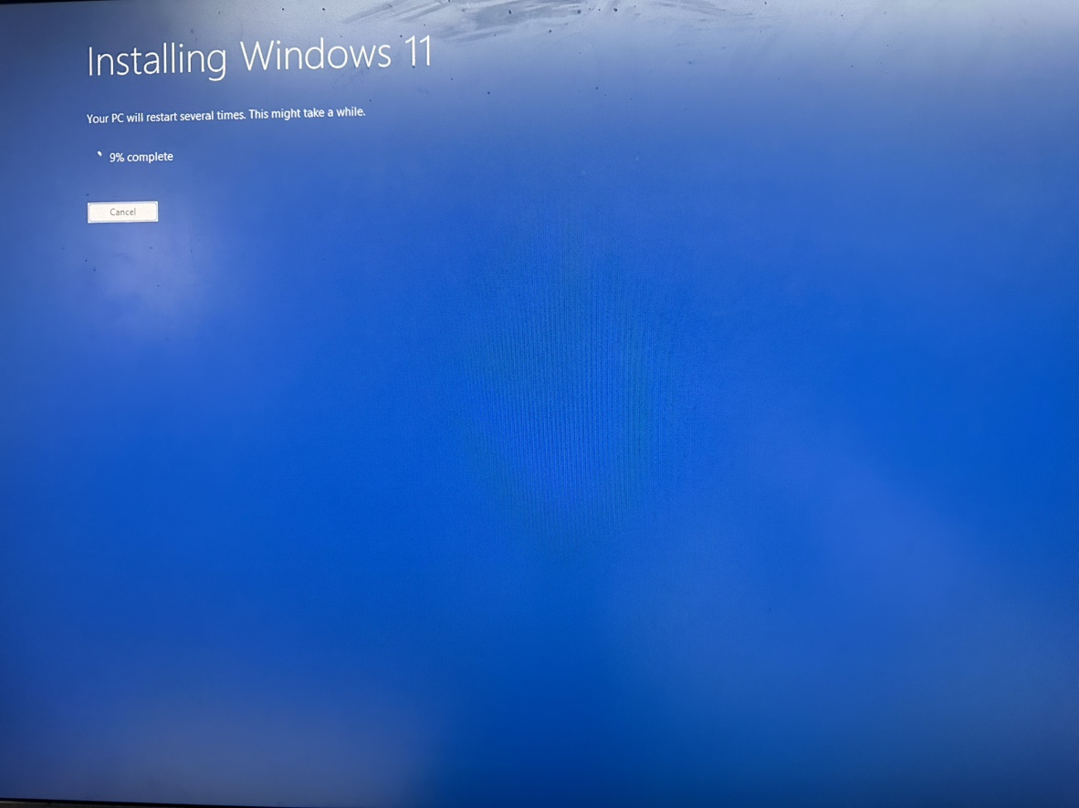

Enter Desktop and Verify Hardware
Action: After completing all initialization steps, the system automatically enters the desktop — OS installation is fully complete. Verification: In Device Manager, confirm that the AMD processor,Radeon Radeon GPU,10GbE and 10 GbE network adapter are all recognized correctly (drivers are pre-included in the image).

Supplementary: Troubleshooting (compute card + included USB drive)
- Cannot enter Ventoy menu: Check that the USB drive is firmly inserted, BIOS boot order is set to USB first, and the image file is in .iso format. If unresolved, try a different USB port on the compute card, or recreate the boot drive using the backup pre-installed image.
- NVMe disk not detected during installation: Verify that the NVMe controller is enabled in BIOS (enabled by default). Re-insert the USB drive and retry. The pre-installed image includes NVMe SSD drivers — no additional drivers needed.
- Hardware malfunction after installation (e.g., 4K output failure): Reinstall using the pre-installed image, which is already hardware-optimized.
- U USB drive not recognized: Use the onboard USB 3.2 Type-C port directly; avoid adapters.
- Remote Desktop connection failed:1.1. Verify the compute card IP (check the RF02 Management Platform);2.2. Confirm Remote Desktop is enabled;3. Check that Remote Desktop option is turned on; 4. Verify a system account password has been set.；
- Compute card not listed in RF02 device list: ① Check the card is in a valid slot (not 4–5, 10–11, or 16–17); 4-5、10-11、16-17 ② Confirm the compute card is powered on (check LCD LCD screen); ③ Check RF02 RF02 chassis power supply is normal.

Install the RF02 Client on the Compute Card
To remotely manage your FXC-A8800 via a web interface, after entering the Windows desktop, first install the client program from the included USB drive. Double-click RF02Client-Setup-v1.0.0.exe on the USB drive. This program, provided by Kiloview Electronics Co., Ltd., is the foundation for enabling core RF02 chassis management functions including remote power on/off, restart, power cut, and quick IP configuration.
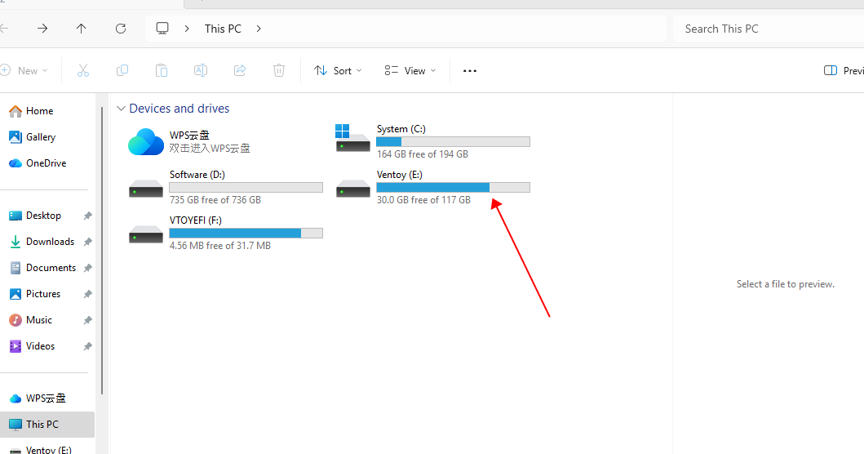
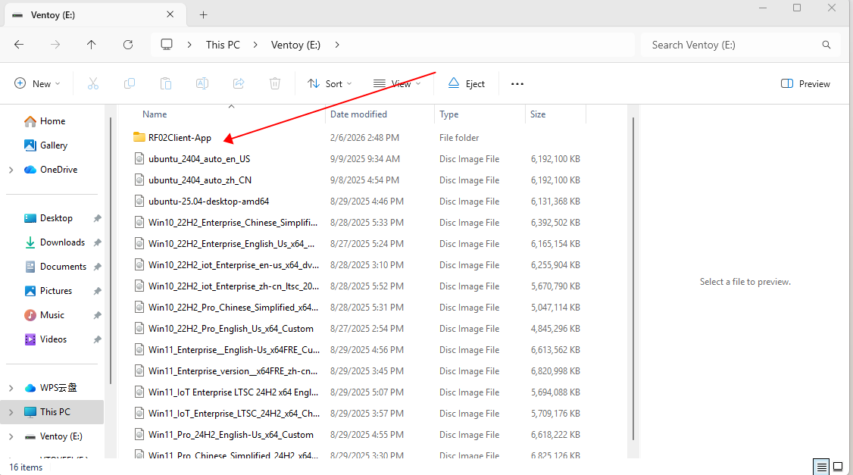
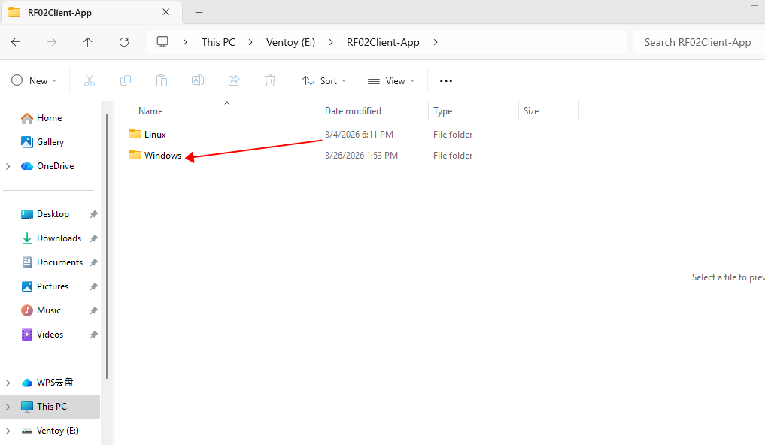
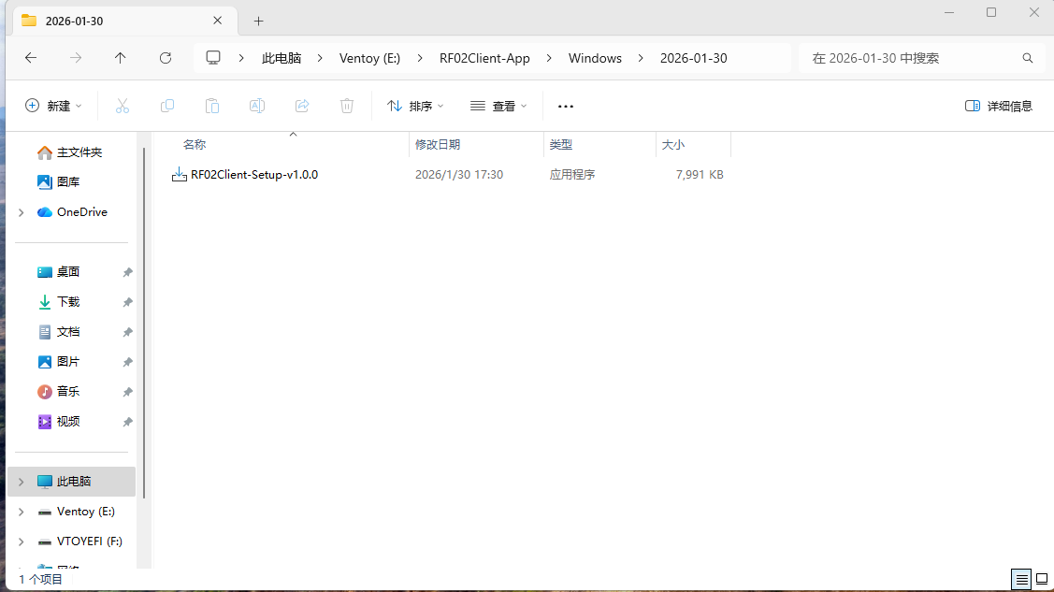
Linux For Linux users, please follow these steps to install the companion tools:
1. Install the package
Copy rf02-client_1.0.0-2_amd64.deb from the installation USB drive to the system, then run:

sudo dpkg -i rf02-client_1.0.0-2_amd64.deb

2. Fix dependency issues (if needed)
If the installation reports missing dependencies, run:

sudo apt-get install -f

3. Verify service status
After installation, verify the service is running with:

sudo systemctl status rf02-client.service

If the service status shows "active (running)", the installation was successful.
Your Linux system now has the same RF02 Windows RF02 management platform capabilities as Windows, and all management services are available.

Note: The latest versions of the RF02 client, compute card BIOS, and hardware drivers can be downloaded from the official Kiloview product page:https://cn.kiloview.com/products/rack/fxc-a8800 Regular updates are recommended to ensure device compatibility and operational stability.

Device Status

Log In to the RF02 Management Platform
Prerequisite: Before entering the compute card IP address in the browser, ensure that your PC and the compute card are on thesame network subnet. If you cannot ping the device IP, check the physical connections and subnet mask settings.
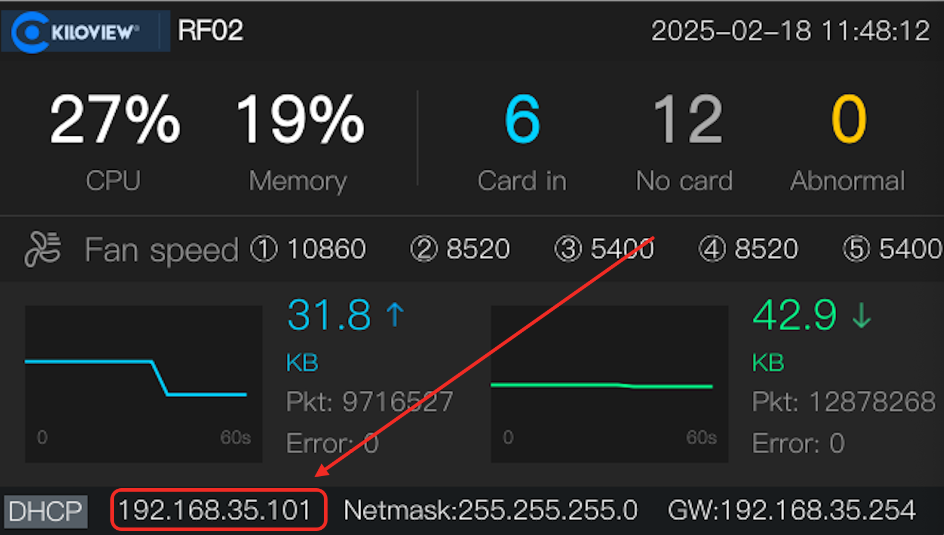
Step 1: Check the RF02 IP address on the LCD home screen and enter it in your browser.
Step 2: Once connected, the RF02 Management Platform login screen appears.
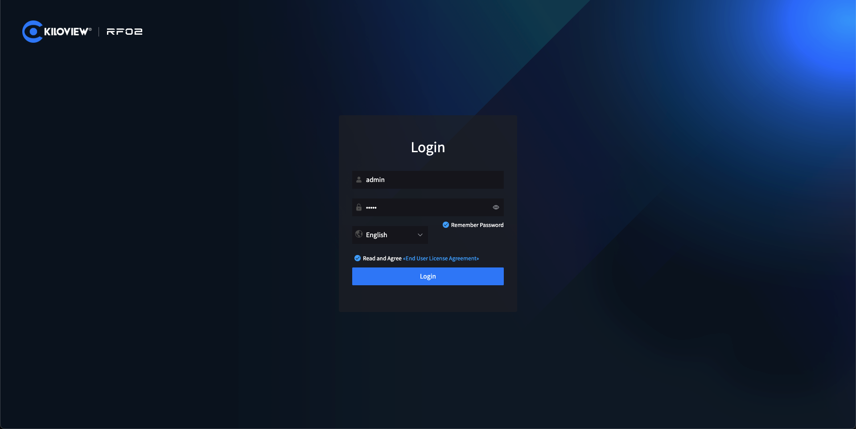

Step 3: Enter the default username and password, then click Login to access the RF02 Management Platform home page.
 | Web Security  - After opening the deviceebweb management interface, the default login credentials are: Username:admin, Password:admin。  - For security, change the default password immediately after first login!  - For browser compatibility, useGoogle Google Chrome or Edge for login.

Module Card Status Display
Use the [<] and [>] keys on the RF02 front panel to browse menus and navigate to the device list. This screen displays all FXC-A8800 compute card information installed in the RF02, showing the card status for all 18 slots and listing detailed information for active module cards, includingthe current IP of each card (DHCP by default), current network up/down speed, and operating temperature.
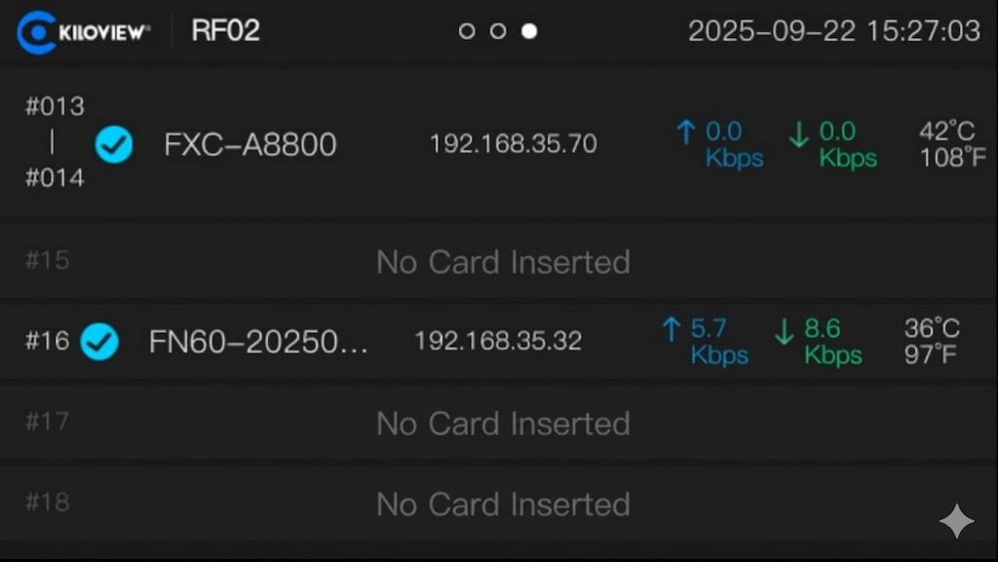

The FXC-A8800 card status can also be viewed on the RF02 Device Management Platform.
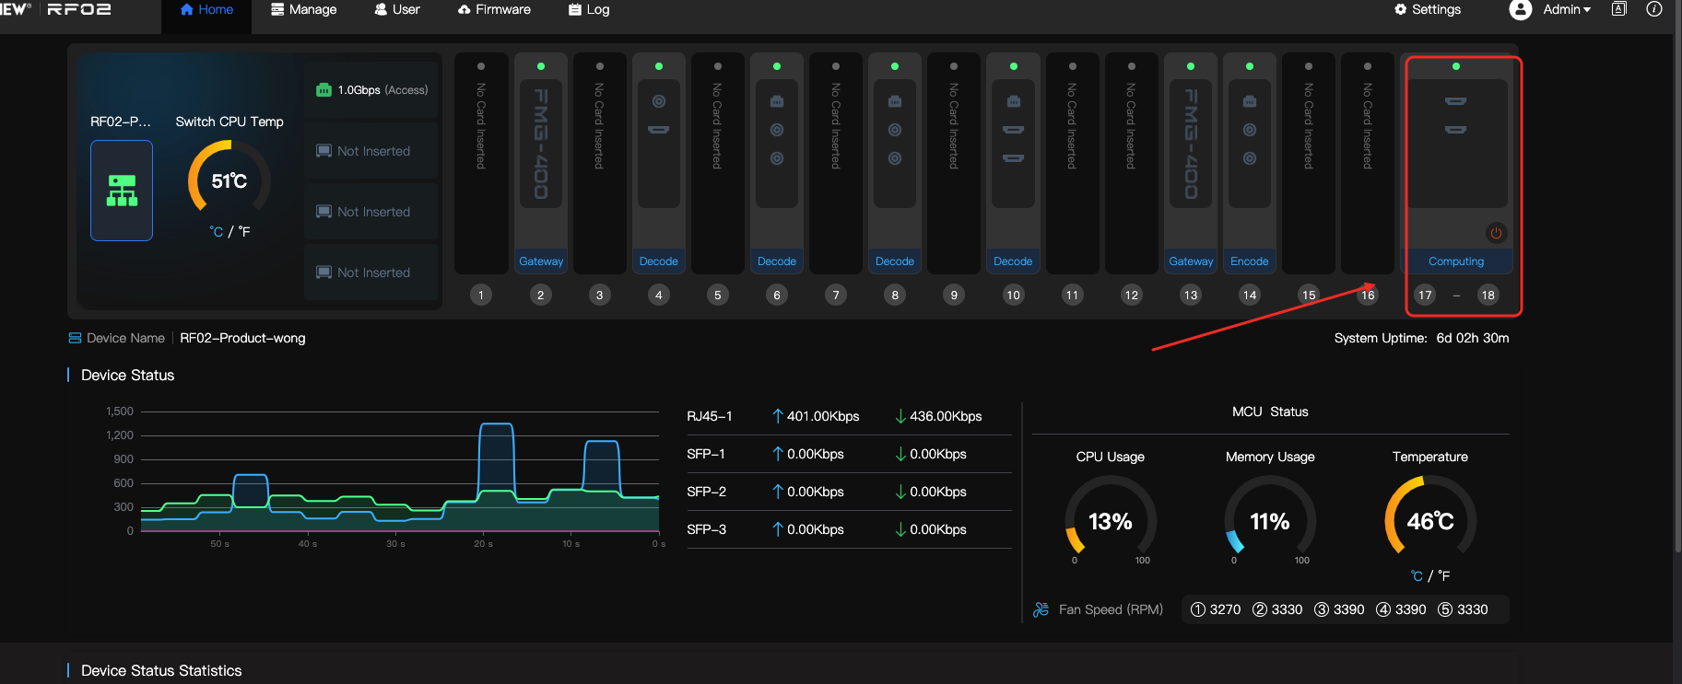
Note
- Default device login username:admin, Password:admin。
- For security, change the default password immediately after first login.

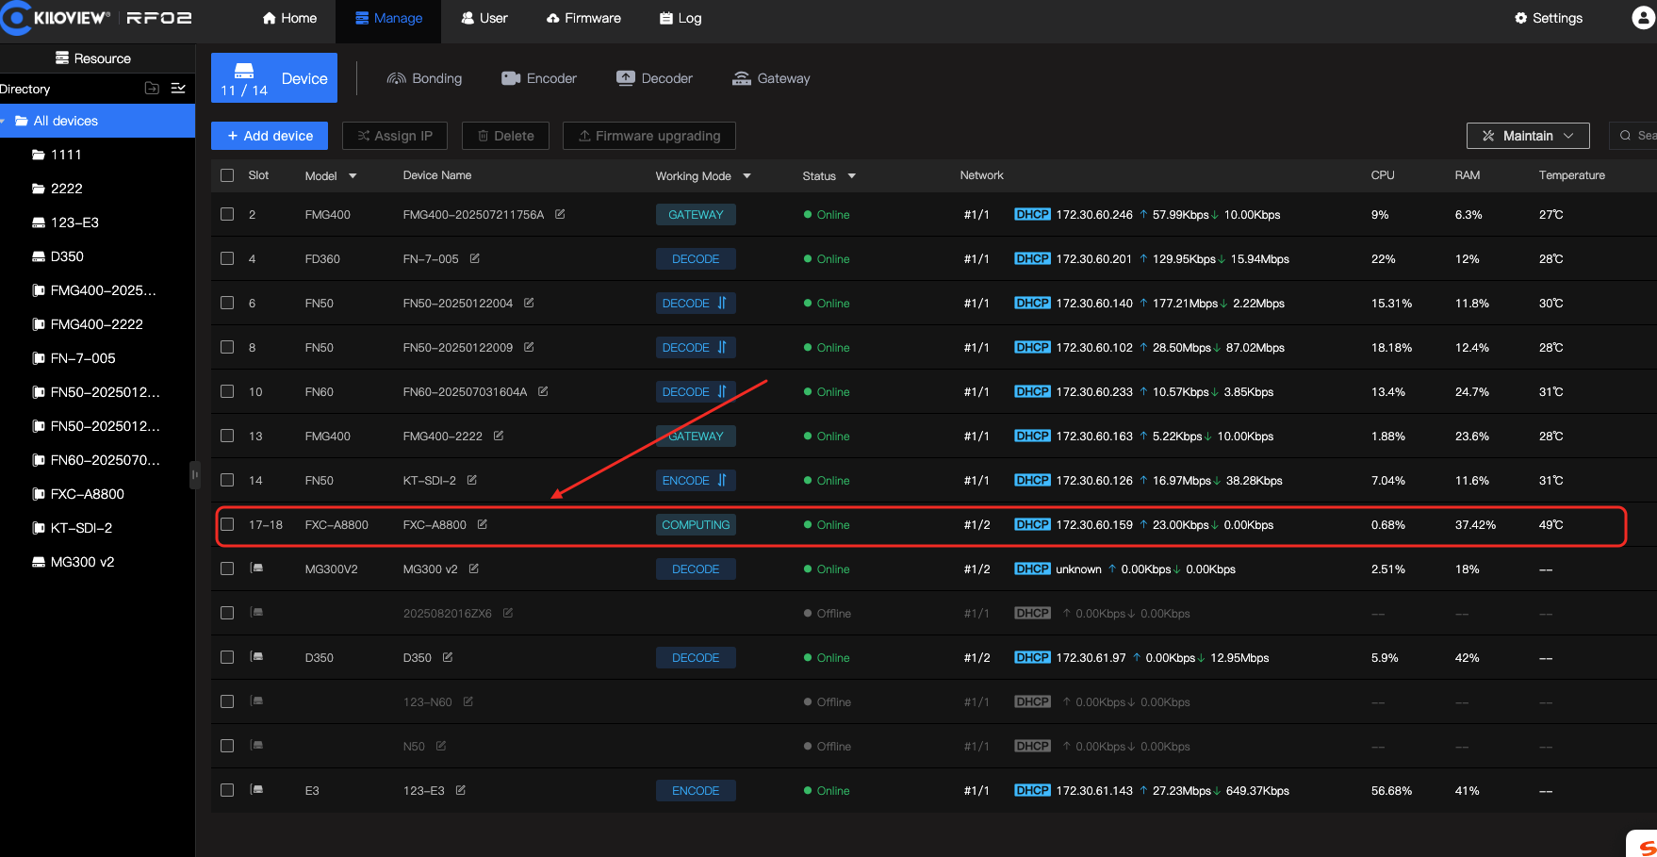

Power On/Off via LCD Screen
From the RF02 LCD device list, press the confirm button to enter edit mode and select the compute card.
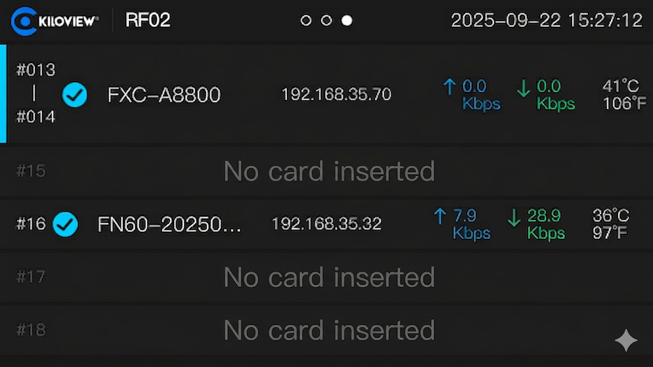
While in edit mode, press [<] to exit edit mode.
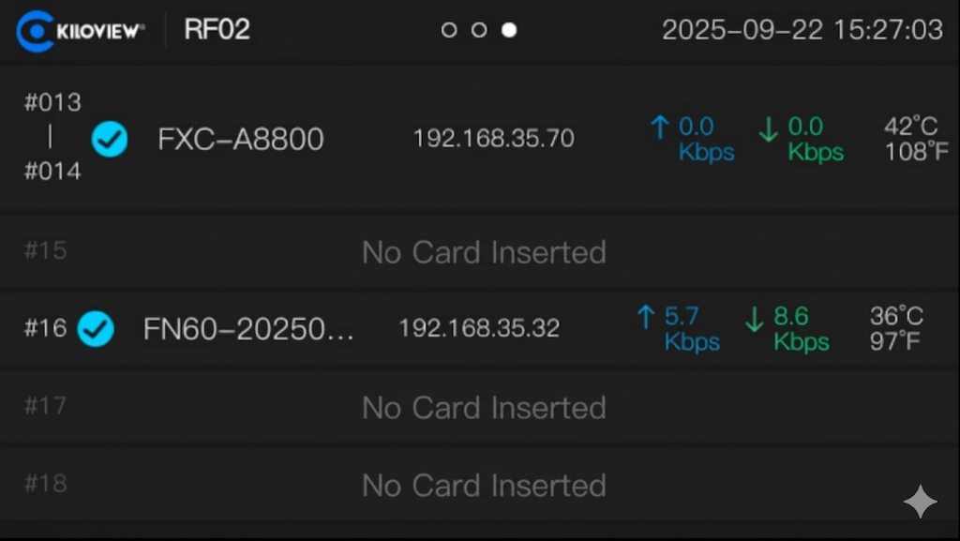

By default, the compute card powers on automatically when inserted into the RF02. When the card is on, you can perform Shutdown, Restart, or Power Cut operations.
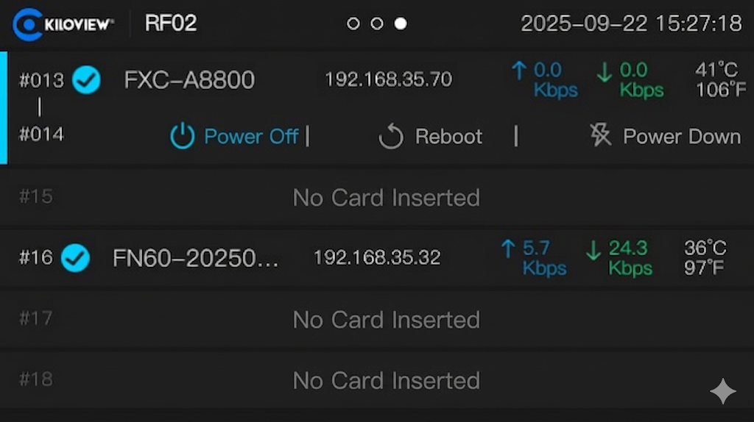
When the compute card is powered off, the edit mode displays a Power On option. Press the confirm button to power on the card.
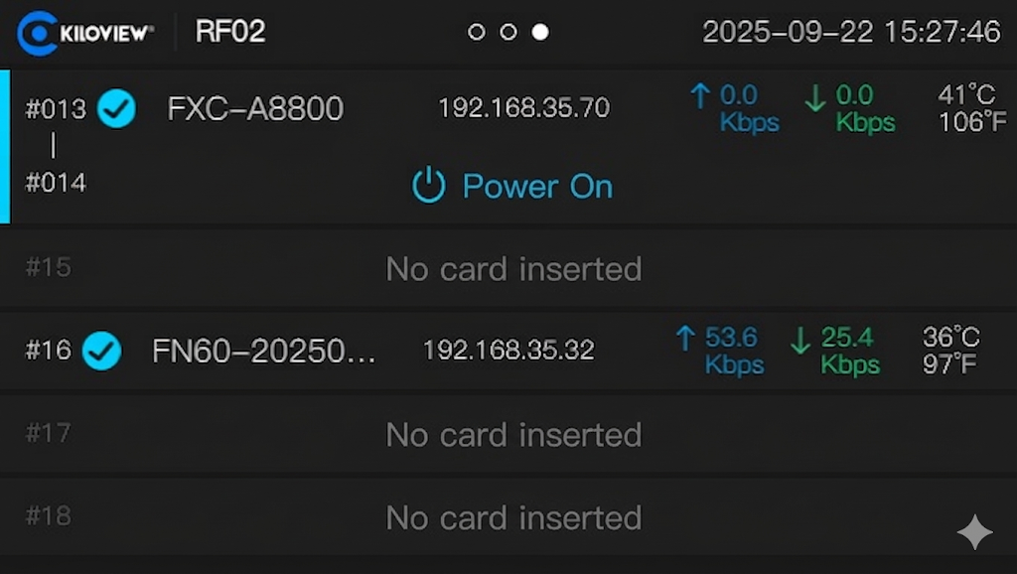
Note
- "Shutdown" performs a normal OS shutdown sequence.。
- "Power Cut" immediately cuts power to the compute card. Use with caution.

Manage Compute Card via RF02 Platform
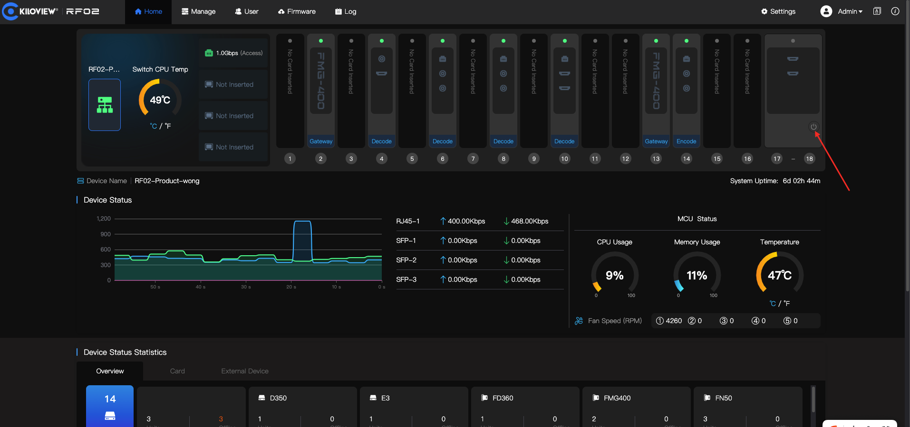

When the compute card is off, click the power button in the RF02 home module list to perform Power On or Shutdown.
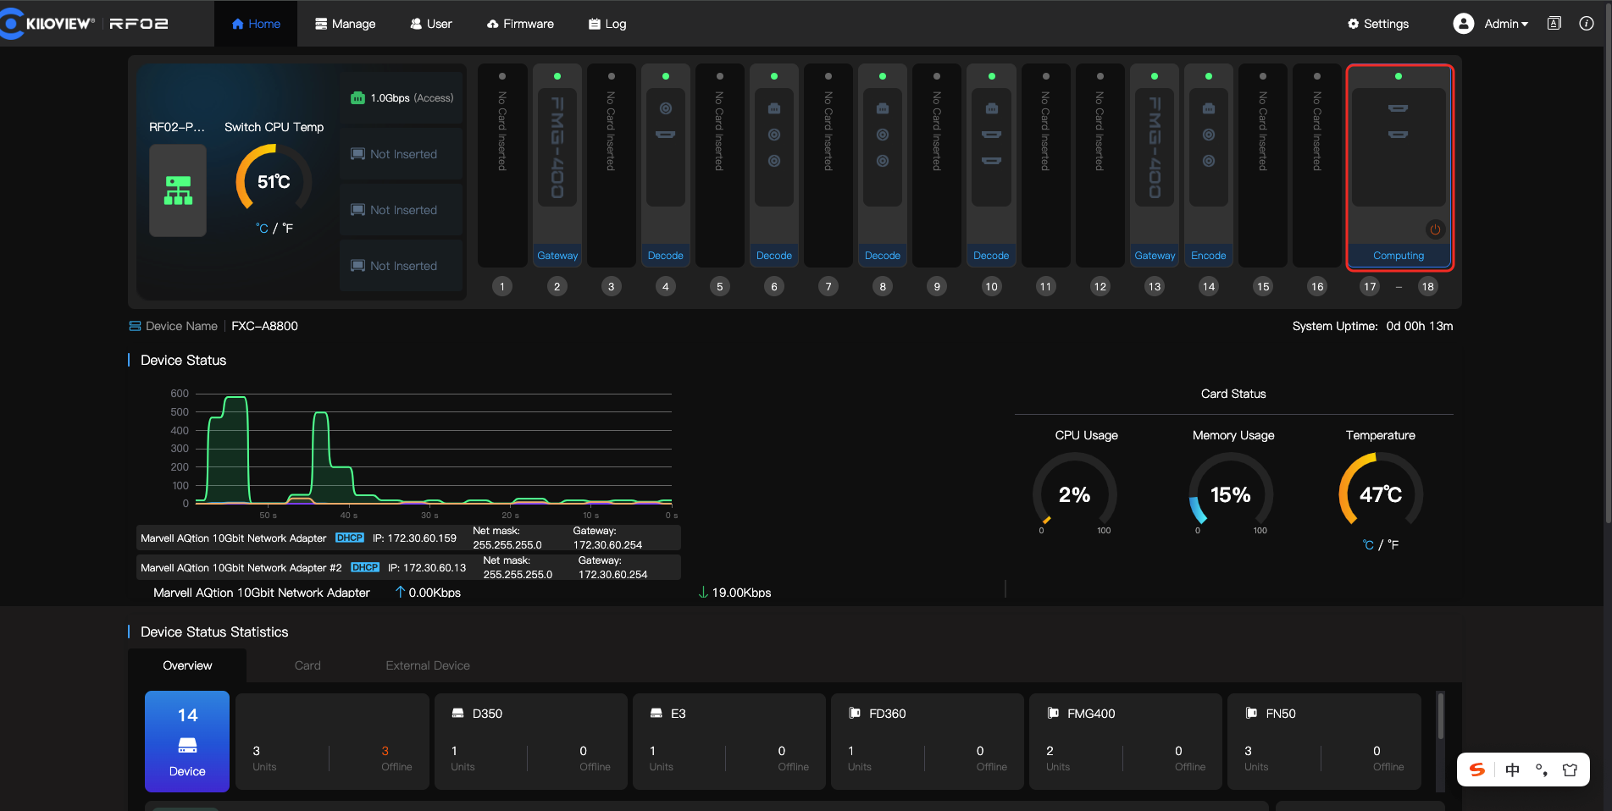

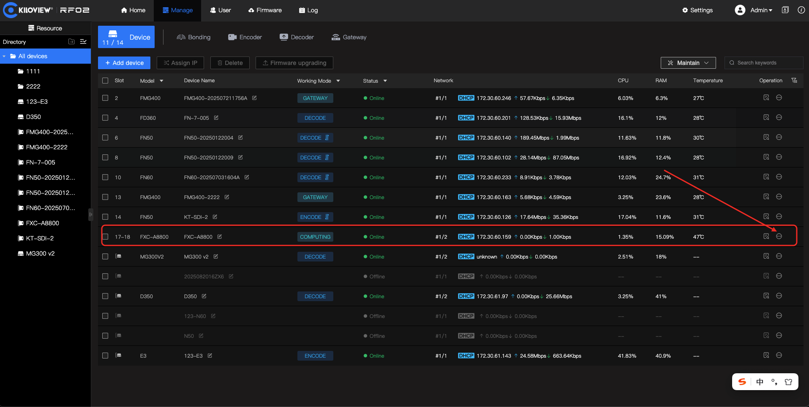
Go to the device list, select the compute card to manage, and click the Operations column.
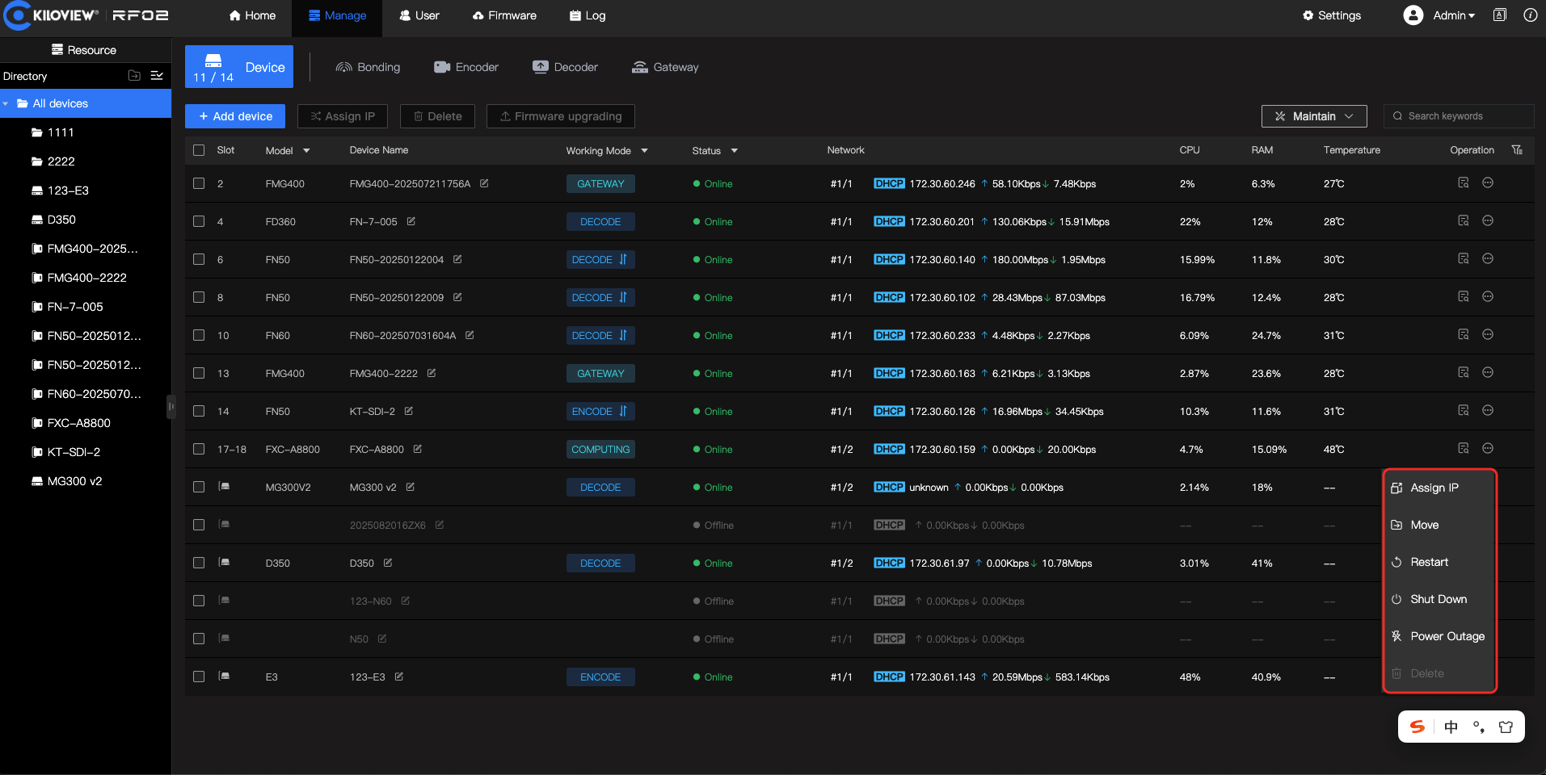
Click the operation button to expand options: Assign IP, Move to Group, Restart, Shutdown, and Power Cut.

Configure Compute Card IP via RF02
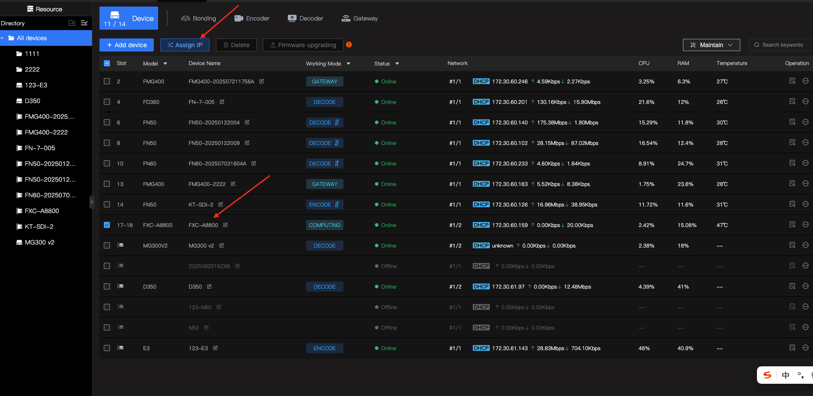
Select the compute card and click the Assign IP button.
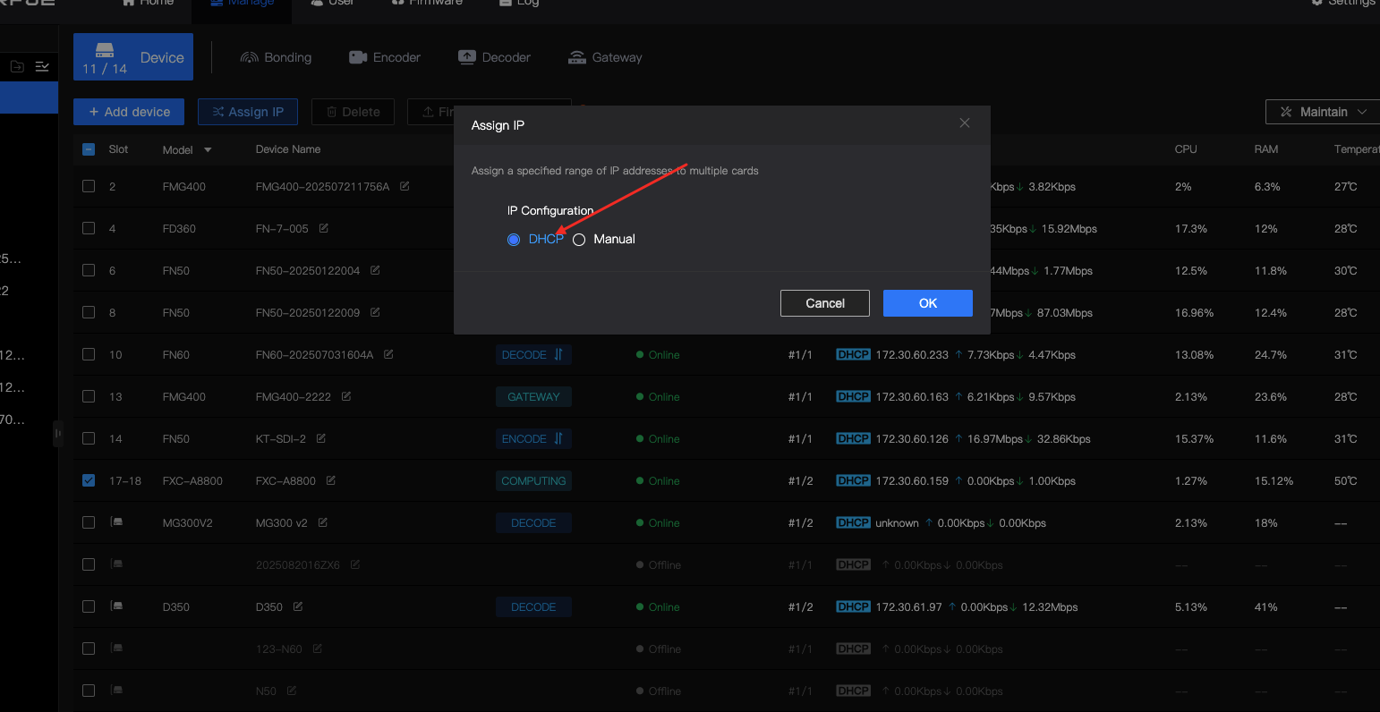
Choose between DHCP (auto-assign) or manually specifying an IP address for the compute card.
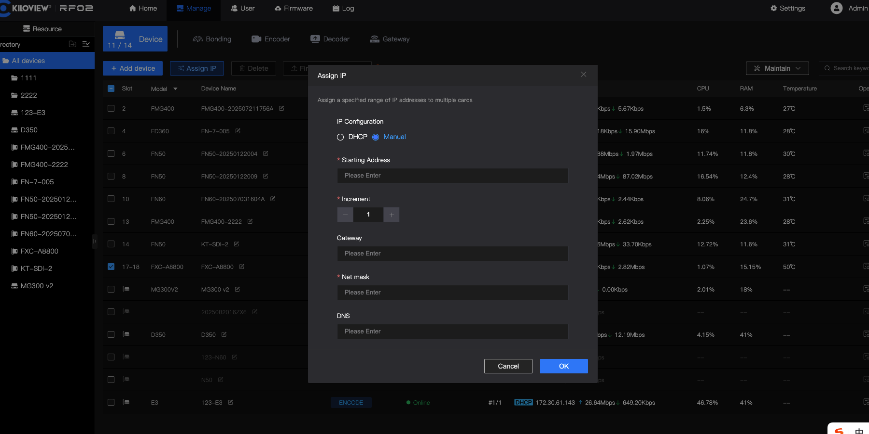
When manually assigning an IP, enter the IP address, gateway, subnet mask, and DNS, then click Confirm to apply.

Manual Power-On
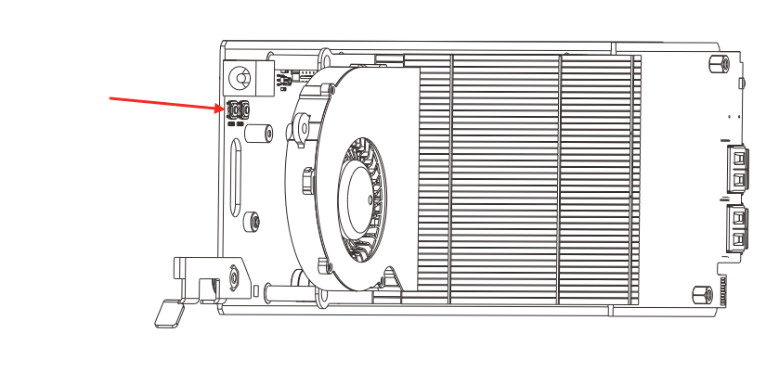
After inserting the compute card into the RF02 and powering on the chassis, the card can also be started using its external power button.

Note
- Close the front panel promptly after completing the power-on action.。
- This function is not recommended for daily use. It should only be used when the compute card cannot be started via RF02.

Remote Control via RF02

Enable Remote Desktop

- After installing the operating system, go to System Settings.Windows 11: Settings → System → Remote Desktop → Enable Remote Desktop → Click Confirm.
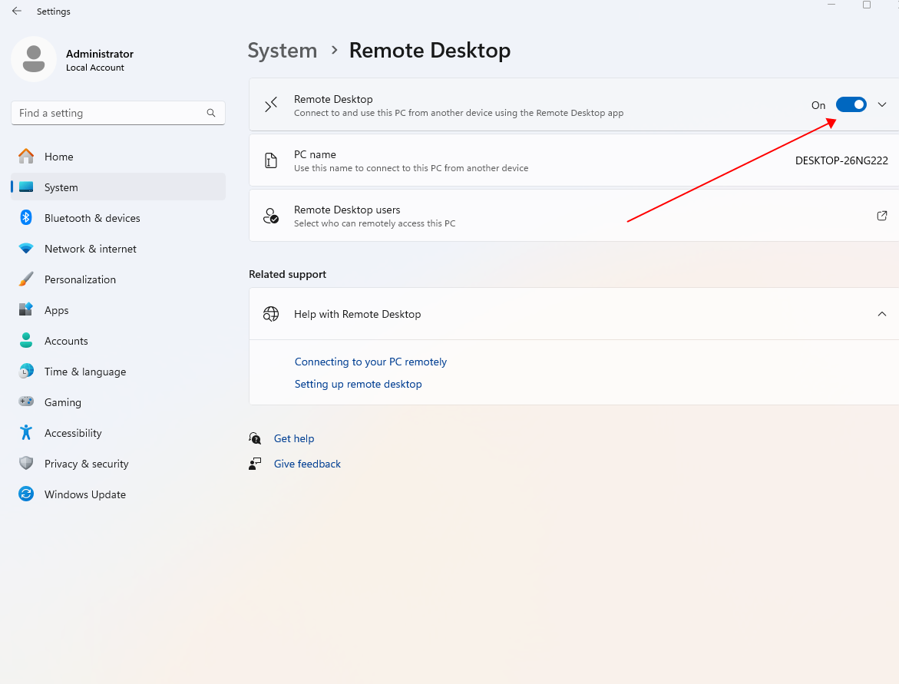

Enable the Remote Desktop feature. Once enabled, remote access is available.

Set Login Password
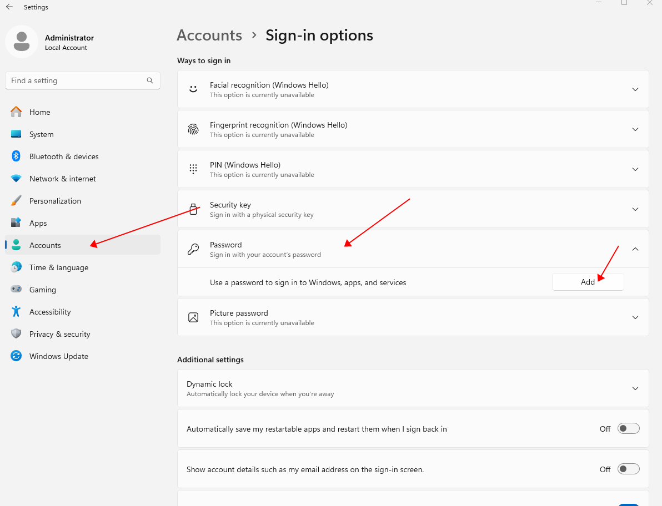
Set a system account password after installing the OS. A password is required for Remote Desktop connections.

Connect to Remote Desktop
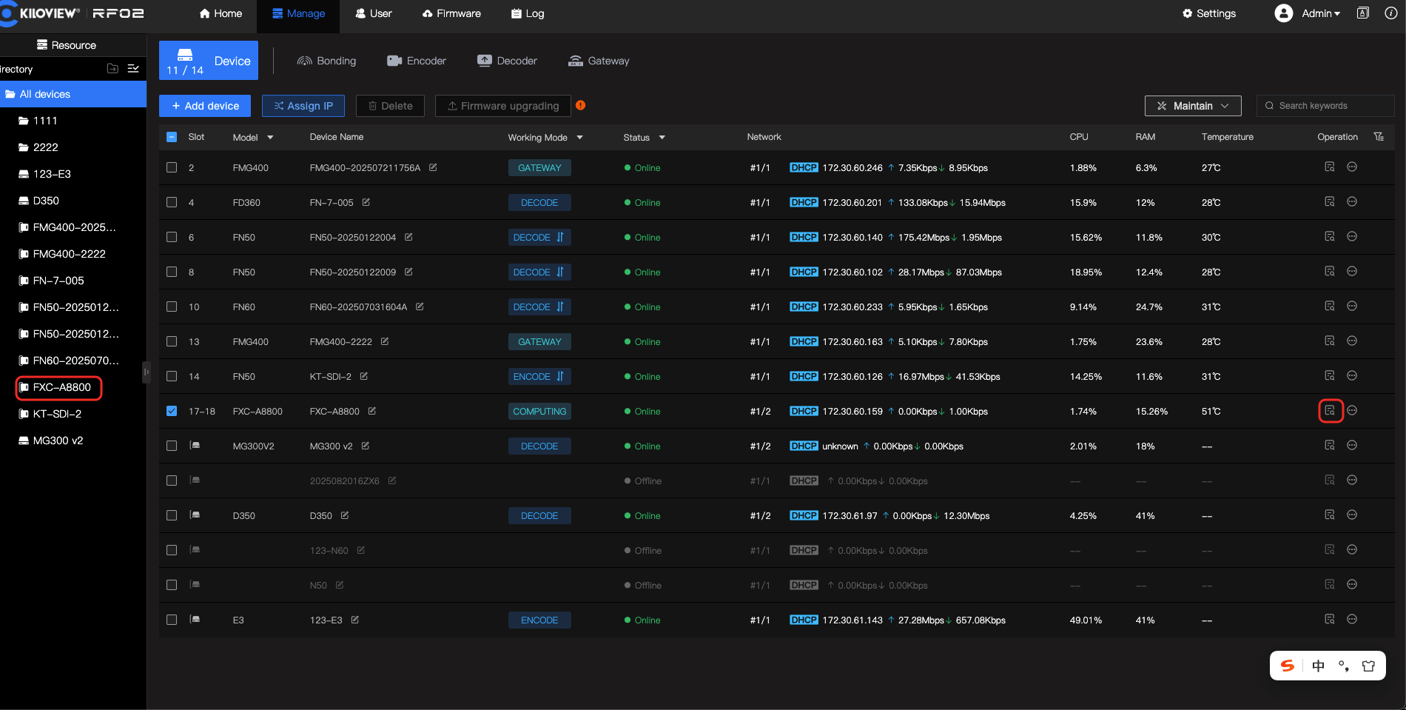
On the RF02 device management page, use the quick-access shortcut on the left sidebar or the Operations button to directly access the FXC-A8800 compute card.
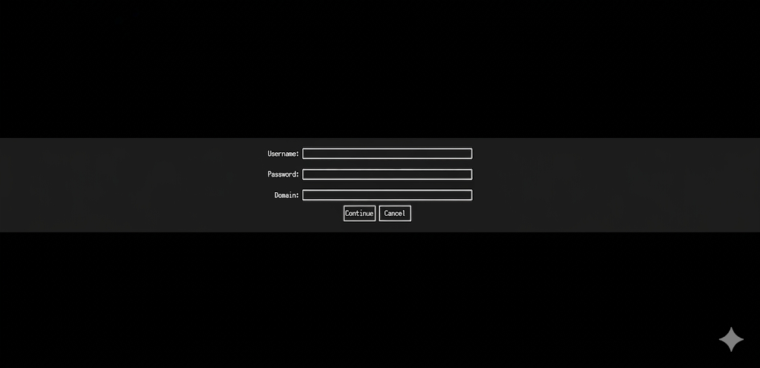
Enter the system username and password to establish the remote desktop connection. (Leave the domain field empty if no domain is configured.)
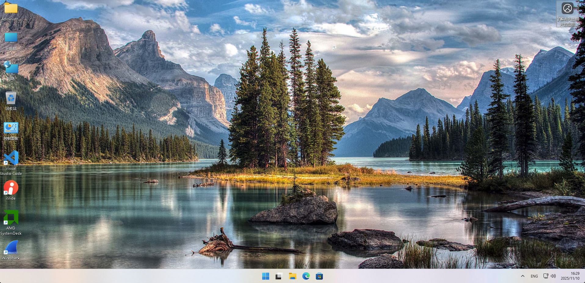
After entering credentials, click Continue to start the remote desktop connection. Once connected, the compute card system desktop appears.

System Links & Network Access
This chapter explains the signal routing rules between the FXC-A8800 compute card and other internal module cards in the RF02 rack-mount media platform, as well as the link logic and configuration requirements for external network access, helping users understand the system data flow and correctly configure and deploy their workflows.

Core Link Architecture
The RF02 rack-mount media platform features a built-in 120 Gbps backplane- bandwidth Layer-3 managed Ethernet switch as the central data hub for all module cards. All cards inserted into the RF02 chassis (including FXC-A8800 compute cards, codec cards, media gateway cards, etc.) connect to this internal switch via the backplane edge connectors, enabling Layer-2/3 inter-card communication without external cabling, unified internal/external network data forwarding, and true plug-and-play operation.

This compute card series has 2 onboard 10 GbE RJ45 ports used exclusively for communication with the RF02 internal switch.There are no external physical network ports. All inter-card data exchange and external network access are routed through the RF02 built-in switch.

Signal Routing Between Compute Card and Internal Modules

Signal Routing with Codec Cards
- Physical Layer Link
FXC-A8800 onboard 10 GbE internal ports -> RF02 chassis backplane edge connector -> Built-in Layer-3 managed switch -> Backplane edge connector -> Codec card adaptive Ethernet port, forming a fully connected physical link.

- When installed in slots 17-18 of the RF02 chassis, the link achieves full
10 Gbps; in other slots, the link supports up to 2.5 Gbps.
- The codec card-to-switch backplane link is 1 Gbps/2.5 Gbps adaptive, meeting the low-latency transmission requirements for 4K AV streams.

II. Data-Layer Routing & Traffic Flow

- Uplink (Encoder Card → Compute Card)
Codec cardscapture SDI/HDMI baseband video signals, encode them into standard protocol IP streams (NDI High Bandwidth, NDI HX2/HX3, SRT, RTMP, etc.), and push them directly to the FXC-A8800 compute card via the RF02 internal switch. Production software on the compute card (vMix, OBS Studio, etc.) can directly consume these IP streams for multi-camera mixing, editing, color grading, streaming, and more. All data is forwarded entirely within the chassis, with no external network required, achieving frame-level latency.
- Downlink (Compute Card → Decoder Card)
The program output (PGM) stream and finished AV streams processed by software on the FXC-A8800 are sent directly to codec cards via the RF02 internal switch. Codec cards decode the IP streams back to SDI/HDMI baseband signals for delivery to monitors, matrices, recording devices, and other peripherals — completing the end-to-end AV production workflow loop.
III. Routing Configuration Notes
- All cards are shipped with DHCP enabled by default. The RF02 built-in switch assigns same-subnet IP addresses uniformly. Cards within the same chassis auto-discover and communicate with each other — no manual static routing is required.

- Maximum inter-card bandwidth is limited by slot speed. For multi-channel 4K concurrent processing, install the compute card in the full-speed slots 17–18.

Signal Routing with Media Gateway Cards
I. Physical Layer Link
FXC-A8800 Compute Card -> RF02 backplane edge connector -> Built-in Layer-3 switch -> Backplane edge connector -> FMG-400 Media Gateway Card,sharing the same backplane switching architecture as the codec cards.

II. Traffic Flow Logic
- The FMG-400 handles multi-protocol conversion, multi-bitrate transcoding,and multi-stream distribution. Single-protocol IP streams output by the compute card can be pushed to the FMG-400 via the internal switch and converted to SRT/RTMP/RTSP/HLS for simultaneous delivery to multiple streaming platforms and remote endpoints.
- Remote SRT/RTSP pull streams and P-series bonding encoder return feeds received by the FMG-400 can be forwarded directly to the compute card via the internal switch — no external cables needed — enabling local production of remote signals.
- Traffic between the compute card and FMG-400 is automatically routed within the same subnet by default.

External Network Access to the Compute Card

Core Access Rules
FXC-A8800 The compute card has no external physical network interface. All LAN / WAN access and connectivity must go through RF02 the RF02 rack-mount media platform's external network interfaces, which relay traffic through the chassis's built-in Layer-3 switch. Direct external cable connection to the compute card is not supported.

Physical Layer Link
External network (LAN/WAN) → RF02 chassis external network port → Chassis built-in Layer-3 managed switch → Backplane edge connector → FXC-A8800 compute card onboard 10 GbE internal port, forming a complete end-to-end link.

Available RF02 chassis external network interfaces include:
- 3 × 10 Gbps SFP+ fiber Ethernet interfaces
- 1 × 10 Gbps RJ45 Ethernet interface

Audio Signal Routing & Configuration
This section explains the FXC-A8800 compute card's audio hardware links, system audio device recognition rules, and RF02 the audio signal routing logic with internal RF02 module cards, as well as audio configuration guidance for mainstream mixing / and AV production software, addressing common questions around audio device recognition, routing setup, and mixing operations.

Audio Hardware Interfaces & Core Link Architecture
FXC-A8800 The compute card leverages the AMD Ryzen Embedded 8845HS processor's integrated high-definition audio controller to build alocal hardware output + + internal IP IP stream dual-rail audio link architecture. All audio signal processing is handled by the CPU integrated audio unit and Radeon 780M GPU collaboratively, with no external audio capture card required for broadcast-grade audio processing.

Onboard Audio Output Interfaces & Link Characteristics
Interface | Link Characteristics | Audio Output Capability | Typical Use Case
3.5 mm Line Out | Independent analog line output,driven by CPU integrated audio controller | Dual-channel stereo line-level output; up to 48 kHz/16-bit; no headphone amplification | Connect to mixing consoles, powered speakers, amplifiers and other professional audio peripherals
HDMI 2.1 Output | AV sync output channel driven by Radeon 780M GPU | 8-channel lossless audio sync with video; 48 kHz/24-bit HD | Connect to audio-capable monitors,TVs, and production switchers
USB 3.2 Type-C（DP 1.4 Alt Mode） | AV sync output channel driven by Radeon 780M GPU | 8-channel lossless audio sync with video; 48 kHz/24-bit HD | Connect to Type-C monitors, capture cards, and portable displays
Core Audio Signal Chain

Input chain: IP audio streams from RF02 codec / gateway cards → RF02 backplane built-in switch → Compute card 10 GbE internal port → System audio driver → AV / mixing software.
Processing chain: Mixing software completes multi-track mixing, effects processing, and level adjustment, then outputs to the system audio playback device.
Output chain: System audio playback device → Corresponding hardware interface (3.5 mm Line Out / HDMI / Type-C) / RF02 internal switch → Local audio peripherals.

System-Level Audio Device Recognition & Basic Routing
I. Windows Windows Audio Configuration
1Audio Device Recognition
After booting into the OS, the following default audio playback devices are automatically recognized — no additional drivers required:

- Speakers (Realtek(R) Audio): maps to the 3.5 mm Line Out — the system default playback device.
- AMD High Definition Audio Device: maps to the HDMI/Type-C audio output channels. Each connected audio-capable display generates a separate audio playback device.

Basic Routing Setup Steps
-  Right-click the volume icon in the system tray (bottom-right) and select Sound Settings.

-  In the Output list, select the target playback device and click Set as Default to configure the system's main audio output route.

-  To adjust individual device audio properties, click the device,→ then Properties, to configure sample rate, channel format, and volume level.3.5mm The 3.5 mm Line Out is recommended to be set to48kHz/16bit stereo to match professional audio peripheral standards.

Key Notes
-  The 3.5 mm port on this product is aLine Out (not a headphone output). It has no headphone power amplification. Do not connect passive high-impedance headphones directly — this will result in very low or no volume.

- When multiple HDMI/Type-C ports are connected to displays simultaneously, manually designate a single default playback device in the system to prevent audio output from being distributed across multiple devices.

II. Linux Audio Configuration
1.Audio Device Recognition
The system drives onboard audio devices via PulseAudio/ALSA by default, automatically recognizing:
- Analog Stereo Output (Line Out): maps to the 3.5 mm Line Out.
- HDMI/DP Digital Audio Output: maps to HDMI/Type-C audio channels.

Basic Routing Setup
- GUI: Go to Settings → Sound → Output tab, select the target playback device, and set it as the default output.
- Command line: Use pactl list sinks to view all audio devices, and pactl set-default-sink [device-name] to set the default output.

Audio Configuration for Major AV / Mixing Software
I. vMix Pro Audio Optimization

- Default Audio Device Routing
Open vMix Pro, go to Settings → Audio Settings. Set the Master Audio Output Device to the system default (3.5 mm Line Out / HDMI audio). The Monitor Output Device can be set separately to an external headphone monitor or powered speaker for independent dual-channel routing of program and monitor outputs.
- Input Source Audio Routing
When adding NDI/network stream input sources, check Auto Activate Audio Tracks — the software will automatically detect multi-track audio in the stream without manual decoding.
Each input source can be managed through the Audio Mixer panel — set channel mapping, level adjustment, and effects processing, with independent routing to main output, auxiliary output, and monitor channel.
- Optimization Settings
Enable Hardware Audio Acceleration to reduce CPU usage and avoid audio glitches or popping under heavy load.
Set the audio buffer to 20–50 ms to balance latency and stability; 50 ms is recommended for live streaming, 20 ms for local production.
Enable Auto A/V Sync Calibration to prevent audio-video misalignment with multiple input sources.

II. OBS Studio Audio Optimization
- Audio Device Recognition & Basic Setup
Open OBS Studio, go to File → Settings → Audio. Under Global Audio Devices:

- Desktop Audio: select the system default playback device to capture system audio.
- Mic/Auxiliary Audio: select an external capture device for voice or commentary capture.
- Set the sample rate to 48 kHz and channels to Stereo for optimal performance with the onboard audio devices.

- Source Audio Routing
● When adding media sources,NDI NDI sources, or network stream sources, check Use Audio from Source —OBS OBS will automatically bind audio and video streams for synchronized delivery.
● Use the Advanced Audio Properties panel to configure monitor mode, volume offset, and channel offset per source. Two modes are supported: Monitor Only and Monitor and Output, for flexible monitoring during mixing.
- Crash & Audio Anomaly Fixes
● Disable Desktop Audio Exclusive Mode to prevent conflicts with the system audio driver that can cause software crashes or silent output.
● If audio popping or stuttering occurs, change the audio buffer time to 40ms ms and disable unnecessary audio filters.
● Prioritize using AMD AMF hardware encoder to ensure synchronized AV encoding and prevent A/V desync during recording / or streaming.

Audio Configuration Troubleshooting
Symptom | Solution
No audio from 3.5 mm Line Out | 1. Verify the default playback device is "Speakers (Realtek(R) Audio)" and volume is not muted/zero.  2. Confirm the connected device is a line-level input (powered speakers,mixer), not passive headphones.  3. Reinstall the original AMD chipset and audio drivers; disable Windows generic driver auto-updates.  4. Check the 3.5 mm cable is firmly connected and functional.
No audio from HDMI/Type-C output | - Verify the display supports audio decoding and volume is  on.  - In system Sound Settings, set the corresponding HDMI/DP  audio device as default.  - In vMix/OBS, confirm the master audio output is set to  the correct HDMI/DP device.  4. Replace the HDMI/Type-C cable and confirm it supports AV sync.
Software cannot detect onboard audio device | - Use the official stable version of software recommended  in this manual; avoid modified or trimmed versions.  - Run the software as Administrator to grant audio device  access.  - Check that the system audio service is running; restart  the Windows Audio service if needed.  - Reinstall the original optimized drivers to ensure  complete audio hardware recognition.
Audio popping, stuttering, or A/V desync | - Check if CPU usage exceeds 90%; close unnecessary  software and effects to reduce load.  - Increase the audio buffer size; disable exclusive mode  to avoid driver conflicts.  - Enable hardware codec acceleration to keep AV encoding  synchronized.  - Verify sufficient network bandwidth with no packet loss  or jitter;NDI protocol is recommended for LAN streaming.

Network Access Configuration
I. LAN Access

- Connect the RF02 chassis 10G RJ45/SFP + external ports to the local LAN switch. Configure the RF02 external interface with an IP in the same subnet as the local LAN IP .
- Via the RF02 Web Management Platform, set the compute card IP IP to a static address in the same subnet as the local LAN. IP；
- Once configured, PCs, storage servers,NDI NDI source devices, and other LAN devices can directly access the compute card — and vice versa — enabling local media retrieval, remote desktop control, and local streaming.

II. WAN Access

- Basic internet access: Connect the RF02 external port to a dedicated internet line. Use the RF02 Management Platform to configure a static public IP IP, gateway, and DNS DNS. Enable port forwarding to map the compute card's Remote Desktop, streaming, and management ports to the public internet for remote access and control.
- Recommended secure access: Use FMG-400 media gateway card's SRT/RTSP secure protocol for safe forwarding of public streams to the compute card, avoiding direct exposure of the compute card to the internet and reducing security risks.

Video Production Software Configuration
This compute card has been deeply performance-optimized for vMix Pro, OBS Studio, and other mainstream broadcast production software. The following recommendations represent the optimal settings based on hardware performance, enabling full use of hardware acceleration for stable operation without stuttering, crashes, or dropped frames.

General Prerequisites
- Before running software, ensure that the factory-optimized AMD chipset and GPU drivers are installed on the compute card, and that power saving and automatic downclocking features are disabled in Windows/Linux.

- Install software on the compute card's onboard NVMe SSD. Do not run software from external USB storage — insufficient read/write bandwidth will cause stuttering.

- For multi-channel, high-bitrate video stream processing, install the compute card in RF02 slots 17–18 to enable full 10 Gbps internal communication speed and minimize stream latency.

vMix Pro Optimization
Version: Use the official stable release of vMix Pro 26/27. Beta, modified, or stripped-down versions are not recommended.

Hardware acceleration: In Settings → Decoders, set the default decoder to Hardware Accelerated - AMD AMF. In Settings → Output, select AMD AMF H.265/H.264 as the encoder and disable x264 software encoding. In Settings → Performance, set the rendering engine to Direct3D 11.

Channel limits: Based on hardware codec capacity — simultaneous encode+decode: H.265 supports 2× 4K@60fps or 6× 1080P@60fps; H.264 supports 1× 4K@60fps or 4× 1080P@60fps; decode-only: 6× 4K@60fps or 17× 1080P@60fps. Do not exceed these limits.

Additional optimization: Keep multiview windows at 1080P or below; apply no more than 3 effects/filters per video source; save recordings directly to the onboard NVMe SSD; disable re-encoding.

OBS Studio Optimization

- Version: Use the official stable release of OBS Studio 30/31. If occasional crashes occur, downgrade to version 29.1.3 stable paired with factory drivers.

- Hardware acceleration: Go to File → Settings → Output, set Output Mode to Advanced, select AMD AMF H.265/H.264 Hardware Encoder, and use CBR bitrate control. In Settings → Video, set Renderer to Direct3D 11 and keep Base Canvas and Output resolution identical. Right-click all video sources and enable Hardware Decoding.

- Scene optimization: Keep the number of video sources per scene within the decode-only limit; disable unnecessary browser sources and transition effects; apply no more than 2 filters per source.

- Crash fixes: Disable Windows automatic generic driver updates; keep the factory-optimized drivers. Disable the Browser Source Hardware Acceleration option in OBS Studio. Avoid running other high-compute applications simultaneously.

General Operating Notes

- During operation, monitor compute card CPU usage, memory usage, and temperature in real time via the RF02 Management Platform. Keep CPU ≤ 90% and memory ≤ 85% to avoid hardware overload.

- In multi-card configurations, install no more than 4 compute cards per RF02 chassis to prevent insufficient power or cooling from causing hardware throttling and reduced software performance.

- If video stuttering or dropped frames occur, first verify that hardware codec acceleration is enabled and that the number of video sources does not exceed the configuration limits. Adjusting these settings should restore normal operation.

Free Trial License Information
Users who purchase FXC-A8800 series compute cards can access free trials of Kilolink Server Pro、Multiview Pro、NDI Recorder Kiloview professional software. Contact Kiloview official channels to obtain the software license.

Storage Expansion Guide
This chapter guides users through installing an additional M.2 NVMe SSD in the FXC-A8800 series compute card. The card comes with 2 M.2 2280 NVMe PCIe SSD slots, supporting user-expandable storage. Read this entire chapter carefully before proceeding to avoid hardware damage.

Before You Begin

- Tools: one Phillips screwdriver of the appropriate size; one anti-static wrist strap or anti-static gloves.

- Hardware: M.2 2280 form factor NVMe PCIe SSD (industrial-grade or genuine consumer-grade NVMe SSD recommended).
❗️SAFETY REQUIREMENT: First shut down the compute card via the RF02 Management Platform. Wait until the card is fully powered off and the indicator LED is off, then fully remove the compute card from the RF02 chassis. Never perform any operation while the card is powered.

SSD Installation Steps
Step 1: Remove the compute card backplate screws
Place the removed compute card on an anti-static surface with the backplate facing up. Use a Phillips screwdriver to remove the 6 baseplate fixing screws indicated by the arrows. Keep the screws in a safe place.
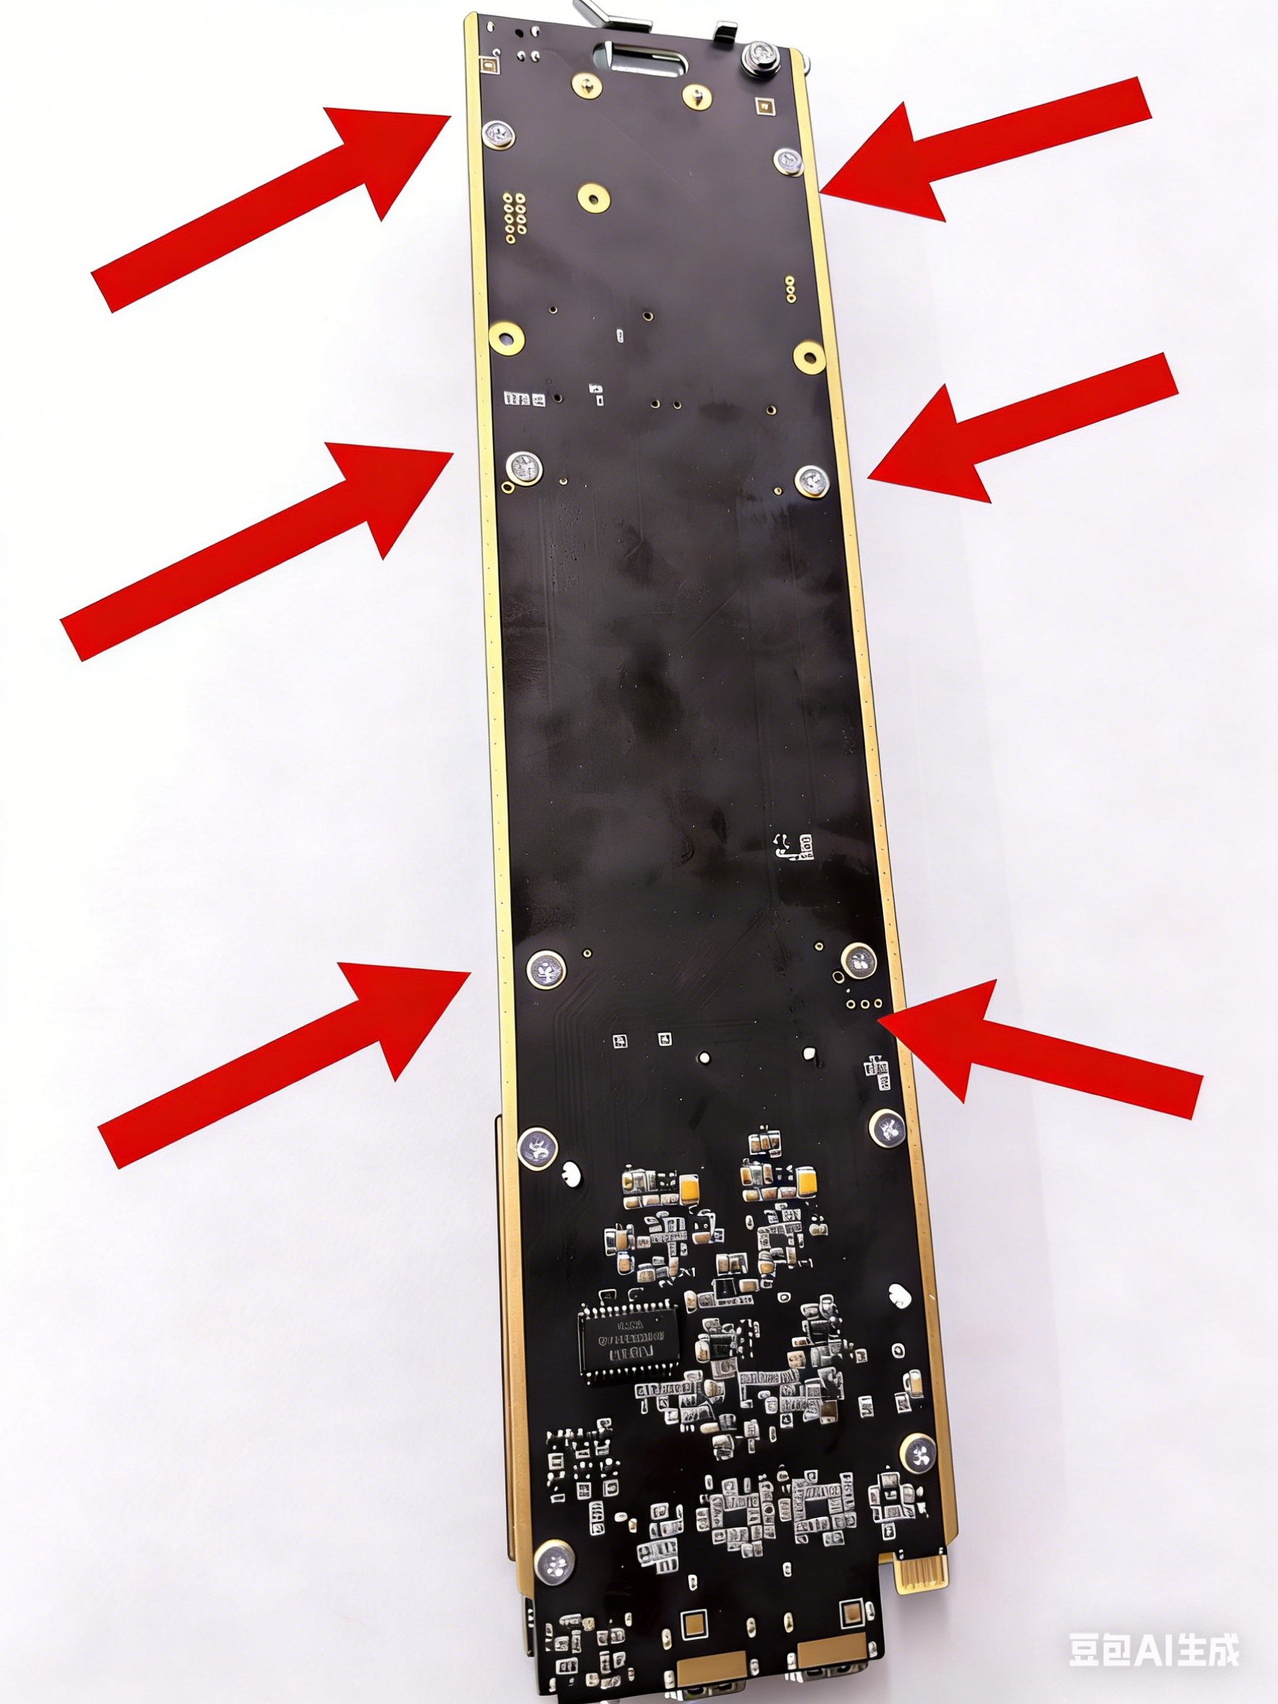

Step 2: Separate the core board from the baseplate
After all 6 screws are removed, carefully separate the core board from the baseplate to expose the 2 onboard M.2 2280 SSD slots. Locate the empty expansion slot (indicated by the arrow in the diagram below).
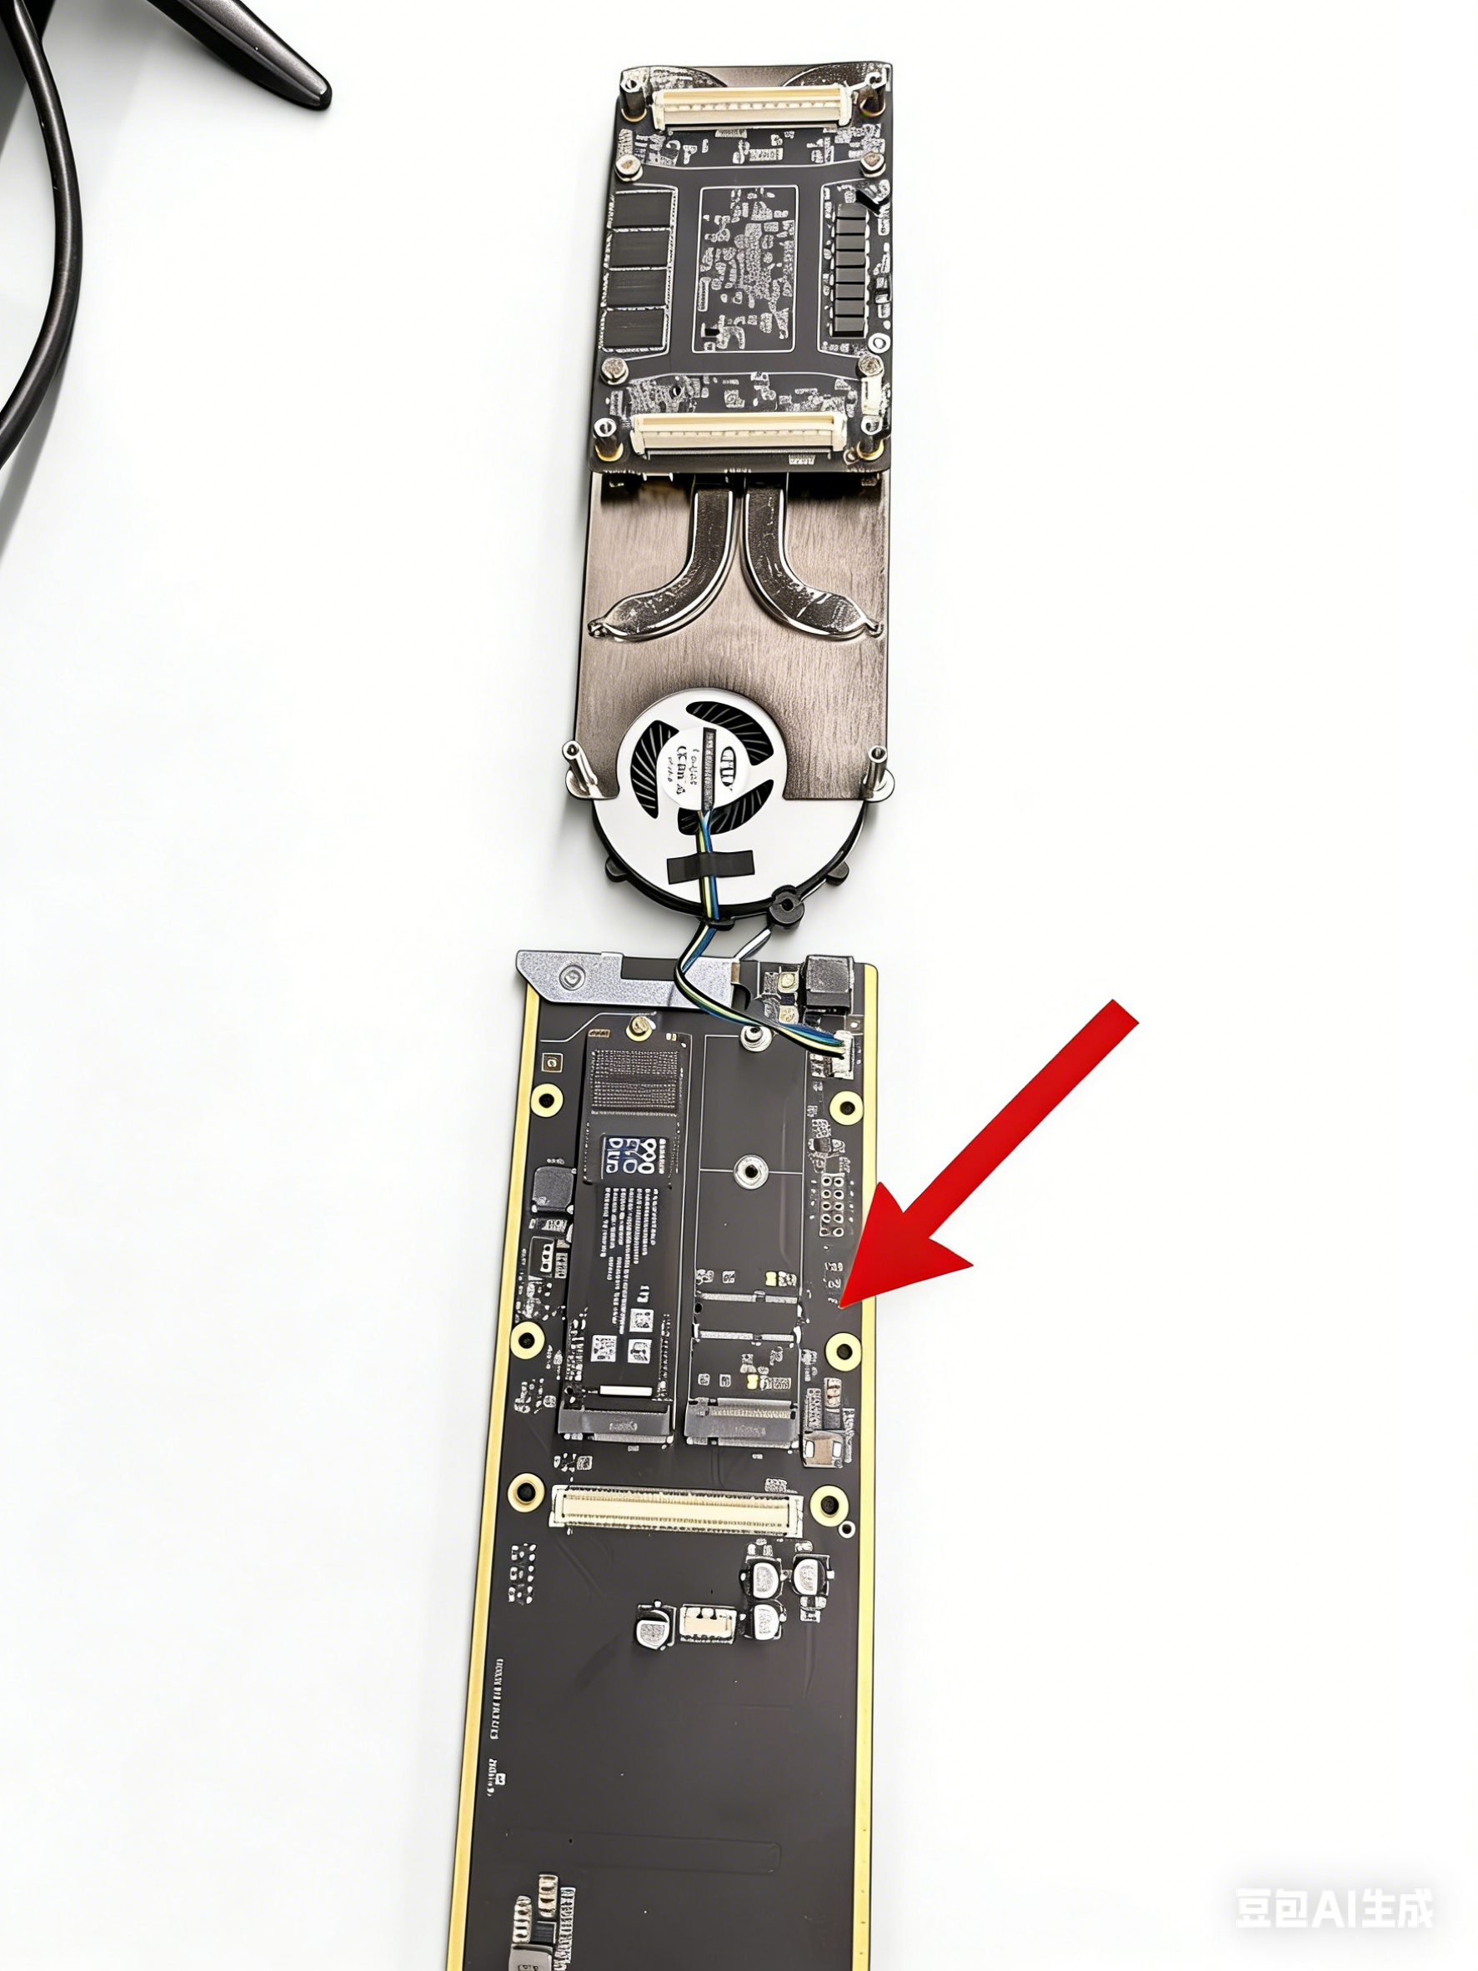

Step 3: Install the expansion SSD
- Hold the SSD by the edge connector end, align it with the empty M.2 slot, and fully insert the connector into the slot to ensure good contact.
- Gently press down the tail end of the SSD to align the mounting hole with the screw hole on the baseplate. Secure the SSD tail with the included screw to prevent loosening or dislodging.

Step 4: Reassemble the compute card
- Confirm the SSD is securely installed and there are no loose screws or
foreign objects inside, then carefully align and mate the core board with the baseplate.
- Replace the 6 fixing screws removed in Step 1, tightening them evenly with a screwdriver to avoid stripping screws or deforming the PCB.

Step 5: Reinstall and verify in system
- Reinstall the completed compute card into the corresponding RF02 chassis slot, following the steps in Chapter 3 (Hardware Installation).
- Power on the compute card. Once in the OS, open Disk Management to detect the new SSD. Complete initialization, partitioning, and formatting before use.

FAQ
This section compiles the most frequently asked questions about installing, using, and configuring the FXC-A8800 series compute card, providing quick solutions for daily operations.

I. Installation & Hardware

Q1: Which slots can the compute card be inserted into? How many can one chassis hold?

Each card occupies 2 consecutive slots. Slot combinations 4–5, 10–11, and 16–17 are forbidden. A single chassis supports up to 4 cards; exceeding this causes power/cooling issues. Slots 17–18 are recommended for full 10 Gbps speed; other valid slots support up to 2.5 Gbps.

Q2: Does the compute card support hot-swapping? What is the proper removal procedure?

Hot-swapping while powered is not recommended. Shut down via the RF02 platform or LCD screen first. Wait until the indicator LED goes off, then release the latch and remove the card. Removing without shutdown may cause data loss or hardware damage.

Q3: No sound when plugging headphones into the 3.5 mm port — why?

The 3.5 mm port is a Line Out, not a headphone output — it has no headphone amplification. Connect it to powered speakers, a mixer, or other line-level devices. Plugging passive headphones directly will produce no sound or very low volume.

Q4: Is it normal for the 4th display to stutter at 4K when all 4 outputs are in use?

Yes, this is expected. When all 4 outputs are active, a maximum of 3 can output stable 4K@60Hz. The 4th port must be set to 2K or below.

II. OS & Drivers

Q1: The USB drive or NVMe SSD is not detected during OS installation — how to troubleshoot?
- USB drive not detected: U Use the compute card's Type-C port; confirm the U drive is set as the first boot device and the image is in.iso format.
- USB drive not detected: SSDNVMe SSD not detected: Reinstall using the pre-installed image (includes adapted drivers); check that the BIOS in NVMe controller is enabled.

Q2: Where can I download the latest BIOS, drivers, and RF02 client?

Download from the official Kiloview product page:https://cn.kiloview.com/products/rack/fxc-a8800 Regular updates ensure compatibility.

III. Network & Remote Control

Q1: The compute card has no external network port — how do I connect it to a LAN or WAN?

Use the RF02 chassis external ports (3× 10G SFP+ fiber, 1× 10G RJ45) for forwarding. The compute card communicates only via its internal ports with the chassis switch; direct external cable connection is not supported.

Q2: Remote Desktop connection fails — what should I do?

Verify the compute card IP is correct, Remote Desktop is enabled, a system password is set, and the firewall is not blocking the relevant port. For public internet access, configure port forwarding on the RF02 platform.

IV. Software Configuration & Usage

Q1: vMix/OBS video is stuttering or dropping frames — what are the key optimization settings?

- Enable AMD AMF hardware codec; disable x264 software encoding.
- Stay within hardware limits: H.265 max 2× 4K@60fps; H.264 max 1× 4K@60fps.
- Disable unnecessary effects; ensure CPU usage stays ≤ 90%.

Q2: OBS crashes intermittently — how can I fix it?

Use OBS 30/31 stable or downgrade to 29.1.3; install factory AMD GPU drivers; disable Browser Source Hardware Acceleration; avoid running other high-compute applications simultaneously.

Q3: How do I obtain a trial license for Kilolink Server Pro and other software?

Compute card purchasers are entitled to a free trial. Contact Kiloview official customer support to obtain the license.

V. Storage Expansion

Q1: What SSD specifications are supported for expansion?

Only M.2 2280 NVMe PCIe SSDs are supported; SATA protocol is not compatible. Single drive maximum: 2 TB; dual slots maximum: 4 TB.

Q2: The system does not detect the newly installed SSD — what should I do?

Verify the SSD is the correct spec and firmly installed. Open Windows Disk Management and initialize, partition, SSD and format the new drive to make it visible.

Thank you for reading!

Kiloview Electronics Co., Ltd.
Phone: +86-731-88315979
Website: www.kiloview.com
Official Weibo: KILOVIEW
Support Email: support@kiloview.com
Support Hotline: +86-18573195156 / +86-18573195256
Address: Building B1, Jiahua Zhigu Industrial Park, 877 Huijin Road, Yuhua District, Changsha, Hunan, China (Zip: 410001)

